**ENVIRONMENTAL SCIENCE SYLLABUS**

**Cross Creek High School**

Instructor: Ms. Charmaine Bridges

Room Number: 501

Email: bridgch@boe.richmond..k12.ga.us

Phone: 706-426-1628 (text preferred)

**Students, Parents, and Guardians,**

Welcome to Environmental Science at Cross Creek High School. I am very excited to engage you in the many topics concerning our environment. During this course, students will focus on human population growth, natural resources, and ecosystem dynamics. The aim of this course is to increase students’ knowledge of the environmental challenges of today, while continuing to cultivate scientific critical thinking skills. I believe your experience in environmental science will be one to remember— the labs are engaging, and the content is a great segway into upper level scientific thinking. Plan to actively participate in class, complete all assignments thoughtfully and on time, and to study regularly outside of class.

**Materials Required Daily:**

1) Pen (blue or black ink only) or Pencil

2) Loose leaf paper and binder

3) Chromebook (charged and ready for use)

**Course Content Standards**

**STUDENTS WILL…**

**SEV1.** Obtain, evaluate, and communicate information to investigate the flow of energy

and cycling of matter within an ecosystem.

**SEV2**. Obtain, evaluate, and communicate information to construct explanations of

stability and change in Earth’s ecosystems.

**SEV3.** Obtain, evaluate, and communicate information to evaluate types, availability, allocation, and sustainability of energy resources.

**SEV4.** Obtain, evaluate, and communicate information to analyze human impact on natural resources.

**SEV5.** Obtain, evaluate, and communicate information about the effects of human population growth on global ecosystems.

**Grading System:**

Students are expected to participate in, and complete all aspects of required work to the best of their ability. Student achievement will be evaluated in a holistic manner, considering all aspects of performance.

Student grades will be recorded in the district mandated on-line portal, Infinite Campus.

**Your grade will be determined as followed:**

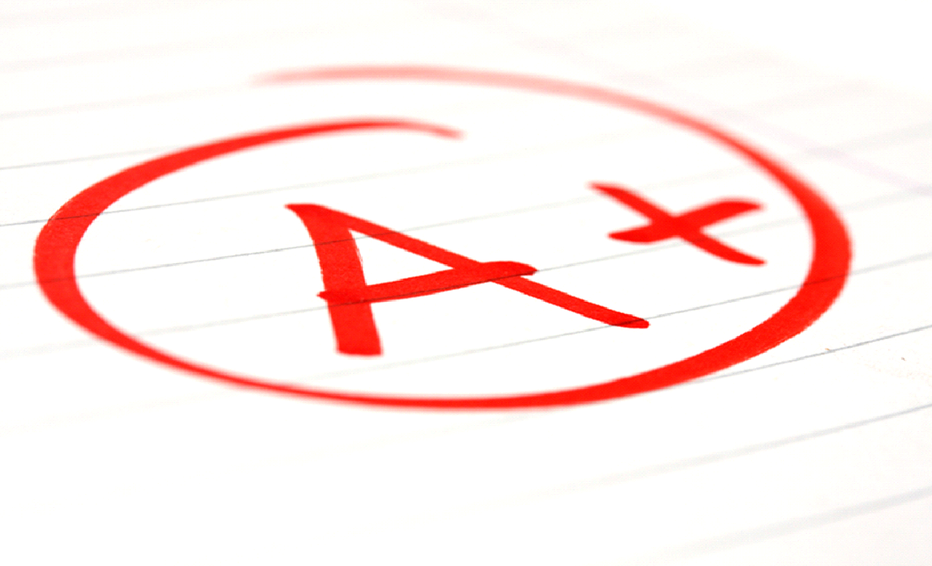

**Minor Assignments 60%**

i.e. Classwork, homework. labs, and quizzes

**Major Assignments 40%**

i.e. Tests and/or unit projects, cumulatives

**CLASSROOM CONDUCT:**

It is necessary for all students to present themselves in a mature and appropriate manner that creates the best learning environment for everybody. Students must maintain respect for themselves, other students, the instructor, and our community at all times. Inappropriate behavior will result in the involvement of the student’s parent/ guardian and the school administration to aid in both correction and disciplinary action.

**Expectations**: All students are expected to follow the rules of the classroom. The rules are posted in the room as a gentle reminder of how you are expected to behave in the classroom. In the event that you decide not to follow the rules, corrective action will be taken.

1. Come to class ready to learn.
2. Be ready to work when the bell rings.
3. Bring all materials needed to class—notebooks, pencils/pens, homework, etc.
4. Actively participate in class.
5. **Refrain from** grooming in class--brushing/combing hair, lotion, nails, applying makeup, etc.
6. Food/candy/snacks/drinks of any kind are **NOT ALLOWED** in class
7. Be responsible for getting the work they miss due to **excused** absences. To get this work you need to **SEE Mrs. Bridges.**
8. **RESPECT** others and other’s property—the school’s, student’s, and teacher’s.—**If it is not yours, please leave it alone.**

## **ATTENDANCE:**

In order to succeed in this class a student MUST be present. After returning from an absence, it is the student’s responsibility to retrieve the assignments and the notes missed when absent for any reason**. Make-up work will only be addressed during independent work time during class. Students must see Mrs. Bridges during tutorial hours** or by appointment to receive any assistance with make-up work. Remember: STUDENTS ARE RESPONSIBLE FOR MAKING UP ALL ASSIGNMENTS AND NOTES MISSED DUE TO AN ABSENCE FOR **ANY** REASON.

**STUDENT SUCCESS:**

I am very interested in the success of every student. If you are having trouble with a particular assignment or concept, do not hesitate to seek help from me. I am available for extra help after school by appointment . Students and parents are encouraged to also use email to contact me at **bridgch@boe.richmond.k12.ga.us**

I am looking forward to an amazing year. We will work and learn together. Please feel free to contact me with any questions or concerns.

Mrs. Bridges