Science Fair Packet

Students/Parents,

Completing a Science Fair project is mandatory for ALL 4th and 5th Grade students. Failure to complete a project in a timely manner will negatively affect your overall grade in STEM Science. If you need any supplies, make sure you see me first. This includes Tri-Fold boards, basic science supplies, glue, food coloring, beakers, etc.

It is important to start working on your project early to ensure you have enough time to develop a hypothesis, gather materials, obtain data, etc. You will find the grading rubric at the end of this document.

Your student will need a folder/binder for TYPED formal report, and finally a Tri-Board for display of their project. You are REQUIRED to have a typed report incldued with your project.

Science Fair projects MUST be completed on a Tri-Board. The Tri-Board WILL BE provided by the school. Students can see me to get one. Projects completed on anything other than a Tri-Board will NOT be accepted

Any item that is required, that is not included in a student’s project will negatively affect the final grade.

**Please be sure that your project is an experiment and NOT just a model. Models can be included as a part of the project if needed. There should be no photos showing any body part including hands on your display board. Take pictures of the actual experiment only.**

This packet and/or any of the sheets inside do not need to be returned to me; it was created to help guide you in the right direction. **Be sure to hold onto this packet and keep in a safe place, as no replacement packets will be given out. If lost, feel free to use the Internet as another resource or guide, as well.**

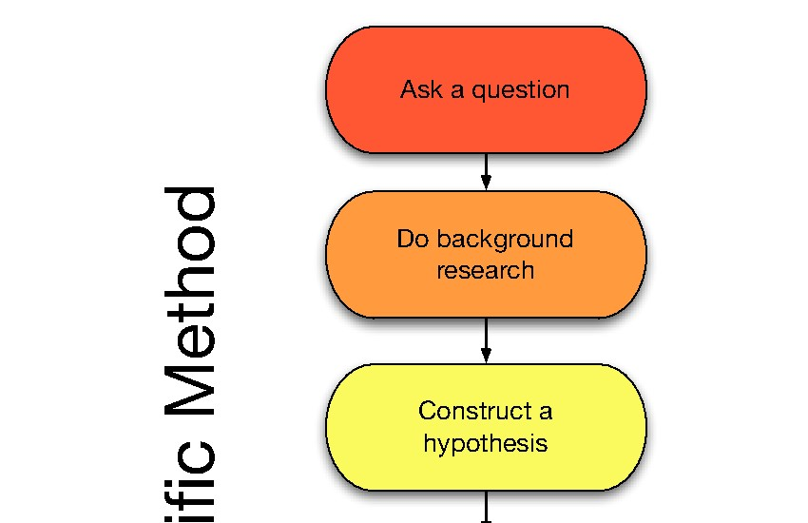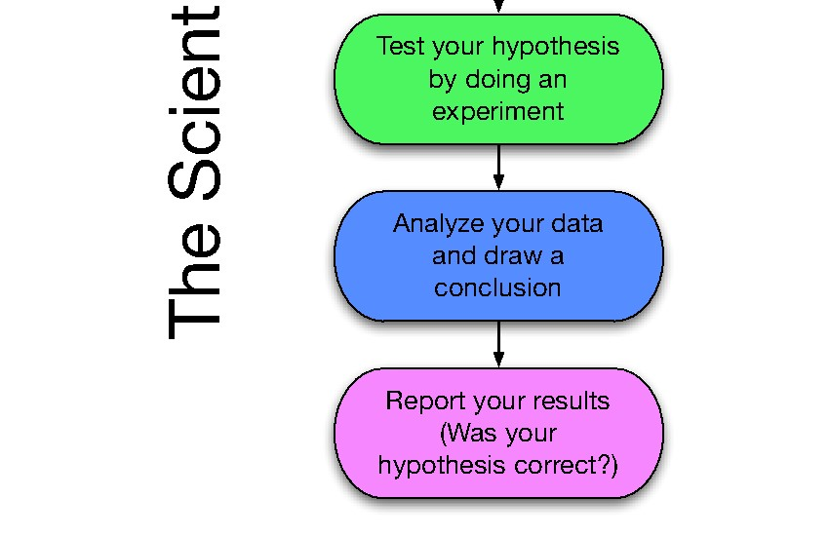

|  |  |  |
| --- | --- | --- |
| **Science Fair Timeline Item** | **Due** | **Details** |
| **Topic & Question** | **Aug 12-15** | **Students should provide a source from which the topic was selected and why they chose this topic.** |
| **Hypothesis, Variables & Materials List** | **Aug 19-22** | **Hypothesis should be formatted with the “If then...because...” statement. A complete list of materials. Provide dependent, independent, and controlled variable(s).** |
| **Procedures/Steps** | **Sep 03-09** | **Students must present specific steps with details.** |
| **Reference List (If applicable)** | **Sep 16-19** | **References to include within the final lab report (number of references required is based on teacher recommendation).** |
| **Science Experiment Work Period** | **Sep 20-Oct 18** | **Students should be conducting their actual experiment during this time period.** |
| **Data Analysis (Graphs, Tables, and/or charts)** | **Oct 21-24** | **Students will present electronic copies of graphs and tables (teacher discretion is applicable regarding written/drawn drafts)** |
| **Results/Findings** | **Oct 28-31** | **Students will provide a minimum of one paragraph (teacher discretion of length) to describe/discuss the findings displayed on their graphs, tables, and/or charts.** |
| **Conclusion** | **Nov 04-07** | **Students will provide a summary (minimum of one paragraph/teacher discretion of length) of their full experiment.** |
| **Completed Experiment** | **Nov 12** | **Students will begin submitting final experiments (Digital Presentation and/or Display Boards, Formal Report, and logbook).**  **\*Final presentations MUST include photos of the student conducting the experiment. \*** |
| **School-Based Science & Engineering Fair** | **Nov 13-Dec 11** | **All school-based science and engineering fairs must be conducted by December 12 with first place winners reported to Dr. Creekmur by December 16.** |



The Scientific Method is an organized way of figuring something out. There are usually six parts to it.

1. **Purpose/Question**- What do you want to learn? An example would be, "What doorknob in school has the most germs?" or "Do girls have faster reflexes than boys?" or "Does the color of a light bulb affect the growth of grass seeds?"
2. **Research**- Find out as much as you can. Look for information in books, on the internet, and by talking with teachers to get the most information you can before you start experimenting.
3. **Hypothesis**- After doing your research, try to predict the answer to the problem. Another term for hypothesis is 'educated guess'. This is usually stated like " If I...(do something) then...(this will occur)" An example would be, "If I grow grass seeds under green light bulbs, then they will grow faster than plants growing under red light bulbs."
4. **Experiment**- The fun part! Design a test or procedure to find out if your hypothesis is correct. In our example, you would set up grass seeds under a green light bulb and seeds under a red light and observe each for a couple of weeks. You would also set up grass seeds under regular white light so that you can compare it with the others. If you are doing this for a science fair, you will probably have to write down exactly what you did for your experiment step by step.
5. **Results/Data**- Record what happened during the experiment. Also known as 'data'. As you observe your experiment, you will need to record the progress of your experiment. Data can be whatever you observe about your experiment that may or may not change during the time of the experimentation. Examples of data are values in pH, temperature, a measurement of growth, color, distance, and etc. Data should be shown in *more than one way*. Examples of ways to show date; graphs, tables, charts, models, pictures, realia, and etc.
6. **Conclusion**- Review the data and check to see if your hypothesis was correct. If the grass under the green light bulb grew faster, then you proved your hypothesis, if not, your hypothesis was wrong. It is not "bad" if your hypothesis was wrong because you still discovered something! Your conclusion should also include next steps.

# The Project Board

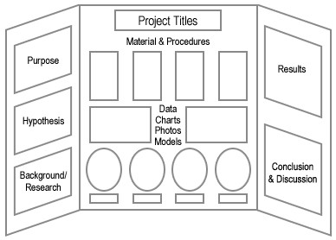

**This is an EXAMPLE board setup**

**Your board should include all the following items to ensure clarity**

**Items in RED are mandatory**

**TITLE and QUESTION** - The title can be the question in a "catchy" form. If your title is different than your question, then make sure you also include your question. Ex. Your question might be, "Which bath soap cleans the best?" but your title might be,

"Splish Splash I Was Taking A Bath."

**RESEARCH** - You have to include a short paragraph that gives the background information on which you based your hypothesis.

**HYPOTHESIS** - This is your educated guess based on your research.

**EXPERIMENT** - This is the procedure you followed to do your experiment. It should follow the scientific method and include:

Materials – Everything you used!

Procedure –Exactly what you did step by step. It should be so clear that someone else could repeat your experiment just by following your steps. Be sure to explain your constants and variables.

**DATA** - These are your results displayed in a way that your audience can understand. It is usually displayed in a table, graph, or photographs. It is an "analysis" of what you have done. You should show your data *in more than one way*!

**CONCLUSION** - This is a statement of whether your hypothesis was right or not; if it wasn't right, why you think it turned out the way it did, and what you would do differently next time.

**EXTRAS** - You should at least do one of the following: ILLUSTRATIONS - These can be photographs that you took or took off the web, that enhance your project. They can also be containers or labels of products you used in your project. ACTUAL MODEL

OR EXPERIMENT - This is the actual experiment you did at home or a model of your topic. Ex. If your question was "Does age affect lung capacity?" you might make a

model of the human lung or have the actual equipment you used to test this experiment.

COLORS AND TEXT**:**  1. You can use the labels that you create on your own. Labels created on the computer can be very effective. Try using a different font or color for each of the labels. 2. Use colors that are appealing. They should contrast with your board color. If you have a white board, make your text a bright color(s). Try backing your text with colored paper to make your words come alive. 3. Type your text or print it neatly. Use stencils or premade letters if you prefer. Make your letterings large enough for everyone to see. If you print it, use pencil first and draw guidelines to make sure your writing is neat. Go over your writing with permanent marker and make sure you erase your guidelines.

DISPLAY YOUR DATA: You may display your data in a table or graph. Make sure your graph reflects the kind of data you have collected.

* A line graph demonstrates change over time.
* A bar/picture graph demonstrates a comparison between two or more things.
* A circle/pie graph compares parts to the whole.

Graphs and tables should be neatly done. Use computer generated graphs and tables or make them yourself. Use a ruler, colored pencils, or markers to make them really eye appealing.

**Written report**

Science Fair Written Report The written report is a summary of everything that you did to investigate your topic. The written report provides others with vital information on what your project is about as well as its effect on your understanding of the topic. Usually, the written report is 5-15 pages in length. All information must be included in the written report. This report provides you with the opportunity to think about all the aspects of our project and share your ideas with others. Reports should be neatly bounded in an attractive binder.

**Your report WILL BE typed.** **You can email me your report to have it printed here at the school.** It will be doubled spaced with one-inch margins, and 12 pt Times New Roman Font. Remember to put headings/titles on graphs/charts/tables. All photographs must have captions explaining their significance. Before you hand in your report make sure to reread, revise, and rewrite. Recheck your calculations, spelling, and grammar. All written report for a science fair project will include:

* Title Page: The first page in the report should include the title of the project as well as the name and grade of the student.
* Acknowledgment: Here is where you thank everyone who helped to make your project successful (including Mom and Dad.) Everyone that you interviewed, including teachers, scientists, and other experts in the field should be mentioned here.
* Table of Content: This page provides the reader with a list of the different parts of the project and the page number on which each section can be found.
* Statement of Purpose: State the purpose of the project in the form of a question.
* Hypothesis: You must have a hypothesis before you complete the project. A hypothesis is an educated guess about what you think will occur as a result from completing your experiment.
* Research: This is the part of the report that contains all the background information that you collected about your topic. Any books or articles read from the internet/journal, authorities on the topic that you talked to, or outside materials collected should be summarized in this section. This section should be written in your own words and NOT copied from your resources.
* Materials: This is a list of all the materials and supplies used in the project. Quantities and amounts of each should also be indicated.
* Procedure: You will list and describe the steps you took to complete the project. Usually this is listed in a numbered sequence. This part shows the stages of the project so that another person can carry out the experiment.
* Observations and Results: In this section, you will tell what you learned from the project. It is also IMPORTANT to include all graphs, charts, or other visual data (pictures) that helps to show your results.
* Conclusion: This is a brief statement explaining why your project turned out the way it did. You should explain why the events you observed occurred. Using the word “because” is a good way to turn an observation into a conclusion. The conclusion should tell whether the hypothesis was proven or not proven. Also give the reason(s) why you chose to learn more about the subject. You could also add what you know now that you didn’t know before you completed your project.
* Reference Page: The bibliography should list all the printed materials the student used to carry out the project. Items should be listed in alphabetical order in a standard format. These websites are a great place to go to find the proper way of writing a bibliography. http://www.bibme.org/ http://www.easybib.com or http://www.knightcite.com Also http://www.Icyte.com lets you “tag” information from Internet sources as you research.

FINISHING TOUCHES:

Make sure you proofread all your written work.

Use rulers to ensure what you write on your board is straight and neat!

Don't use pencils to finish your writing. It looks unfinished, use a pencil as a guide and go over it with pen or marker. Erase all pencil guidelines.

**Sample Elementary Science Fair Questions:**

* What color of candle burns the fastest?
* What kind of paper can float the longest?
* What shape of clay boat holds the most pennies before sinking?
* What happens to cookies when you leave out one ingredient?
* Which kind of cola do people really like the best? (Blind taste test)
* Which kind of detergent washes the most stains out?
* What liquids in my house fizz when I add baking soda?
* What cleans a penny?
* How do different amounts of baking soda affect cookies?
* What food does my pet like best?
* How many seeds do different types of fruit produce?
* How do different style pencils or grips affect writing fatigue?
* What factors affect seed germination?
* What medium is best for seeds to sprout?
* What time of day does a hamster go through a maze faster?
* What type of food or type of birdfeeder attracts the most birds?
* How does smell affect taste?
* Is the heart rate of different animals and people the same after exercise?
* Which gum flavor lasts the longest?
* What product works best to stop stinky feet?
* What temperature makes bread mold grow faster?
* How does egg substitute (or sugar substitute) change recipes?
* Which detergent is best for removing stains?
* What type of paper makes the best paper airplane?
* What is the best type of cup to keep drinks hot? or cold?
* Which type of chocolate melts fastest under a hot light?

**What Makes a Good Science Fair Topic?**

**Ask these questions:**

Is my topic realistic? Is it something I can do? Is my topic interesting to me? Can I investigate my topic by experimenting and collecting data? Can I afford what I will need to investigate my topic? Do I have enough time to complete the experiment?

**Grading Criteria**

Scientific Thought 1 - 5 Points

Creative Ability 1 - 5 Points

Thoroughness 1 – 5 Points

Skill 1 - 5 Points

Clarity 1 - 5 Points

**Scientific Thought:** Is the scientific method followed? Does the project state a hypothesis? Is it testable and well defined? Do the predicted conclusions match the results? If not, is the difference explained? Are organized steps followed, data collected, displayed, and analyzed? Are results displayed and explained?

**Creativity:** Is the experiment original or done in an original way? Does this project stand out from the others? Is approach to solution innovative? Did the student take a project and make it their own?

**Thoroughness:** Is the project organized and logical? How completely was the problem covered? How complete are the project notes? Is the project commensurate with the grade level? Is the project complete, organized, and logical? How clearly were the purpose, procedure, and conclusions discussed?

**Clarity:** Your report will be judged here. The report is mandatory

## Tips on Science Fair Project Success

Science fairs are a great opportunity for students to show off what they know about science with engaging, well-researched projects that clearly answer a specific hypothesis. All students want their science fair projects to succeed, and by following a few simple tips and ideas, they can be off to a promising start.

Choose a Good Topic

Choosing the right topic is the first step toward a successful science fair project since it determines the course of the entire project. Don't just pick the first topic that comes to mind; do your homework and find out if your topic has been researched before and what similar projects have been done and try to determine what difficulties you might face in trying to complete the project. Choose a topic that's simple enough to complete successfully but demonstrates your ability to take on a challenge.

Make a Schedule

Creating a schedule for your science fair project is essential to keeping everything progressing smoothly and giving yourself enough time to complete all the necessary steps. The last thing you want to do is run out of time before the project is completed. Remember to set aside extra time for possible mistakes and re-dos of your experiment, and always budget for more time than you think you'll need. You can never predict everything that will happen with a science fair project, but with some planning, you can make sure you have enough time to deal with it.

Get Expert Help

Although your science project should be your own work, there's no reason not to get a little help with the more difficult aspects. Finding an expert in your project's topic and asking for his advice can actually improve your project and demonstrate that you were willing to go more in-depth with your subject than required. You may want to contact an expert in your topic during the research phase of your science fair project and include his expertise as part of your background research.

Presentation

The way you present your science fair project often determines a significant portion of your grade, so don't neglect the presentation after all your hard work is done. Create an engaging project display that clearly demonstrates what your project is and explains your results. Practice your oral presentation until you feel comfortable saying it by heart and remember to slow down and make good eye contact with your audience when it's your turn to present.

**\*This information DOES NOT go on your display board.**

Once you have chosen your topic, it is important to research the written materials on your subject. By finding out as much information about the subject, you will gain a better understanding of your problem. Follow these guidelines for conducting your research.

1. Read books and articles on your subject. Make sure this information is up to date (not older than 5 – 10 years).

2. Cite your work above your notes.

3. In your report, you will include only your notes from your sources. Use will use these notes to write the research paper in your formal report after you complete the entire experiment.

The following websites are extremely helpful in finding Science Fair project ideas.

http://scienceprojects.com

http://rosearts.org/naples/ideas.htm

http://tetrimore.com

http://www.all-science-fair-projects.com

http://www.factmonster.com

http://www.sciencebuddies.org