**7th Grade Math Summer Assignment**

Click on the link to access the 7th Grade Math IXL summer assignment. This pdf is also in the 7th Grade Math folder where you accessed this document.

[7th Grade Math Summer Assignment.pdf](https://rcboe-my.sharepoint.com/:b:/g/personal/itoca_richmond_k12_ga_us/Eazex0PiQlxNrhvMvc_1k3EBGX5U5etA08QJNA1q63K4rg?e=V0rDkq)

Click on the IXL skill title to access the lesson for that skill or type in the character code after the IXL skill title.

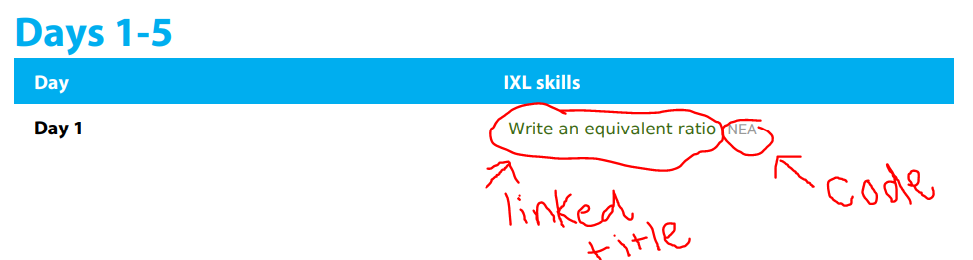

All students have access to their IXL accounts. These were used weekly during the school year.