

Jamestown Elementary School

Mrs. Nesmith

[nesmiyg@boe.richmond.k12.ga.us](mailto:nesmiyg@boe.richmond.k12.ga.us)

706-796-4760

**A note from the teacher…**

Insert a note to parents and students introducing yourself. Include teacher/school qualifications, a few fun facts and/or family information you would like to share.

**Communication:**

What is your preferred method of communication? Do you want to include your cell phone number? (If you give your cell phone number I encourage you to set limits…don’t answer calls/texts after ?:00pm – you determine!). Do you want them to sign up for an app? Include that information here.

**Course Content:** : (insert BROAD grade appropriate content for each area)

|  |  |
| --- | --- |
| **ELA/Reading:** | Students will receive instruction in reading, writing, speaking and listening. |
| **Math:** | Students will receive instruction in addition, subtraction, multiplication, division, fractions, and gathering and interpreting data. |
| **Science:** | Students will gather and interpret data and make models to focus on “doing” science related to earth science, physical science, and life science. |
| **Social Studies:** | Students will receive instruction in geography, economics, history, government, and civics. |

**Course Objectives** (insert more specific objectives for each content area)

|  |  |
| --- | --- |
| **English Language Arts**  Unit 0: Establishing Rituals and Routines  Big Ideas   * Quote accurately from a text * Draw evidence from texts to support writing * Engage in collaborative discussions   Unit 1: Literary Texts Environments   * Narrative Writing * Vocabulary * Ask and Answer Questions * Determine Moral/Theme * Describe Characters & Actions   Unit 2: Informational Texts Interactions   * Informational Writing: How to Article * Vocabulary * Ask and Answer Questions * Main Idea and Supporting Details * Text Structure   Unit 3: Historical Fiction Heroes   * Narrative Writing: Historical Fiction * Vocabulary * Recount Stories * Determine Moral/Theme * Describe Characters & Actions   Unit 4: Biographies (Narrative Nonfiction) Events   * Opinion Writing * Vocabulary * Main Idea and Supporting Details * Point of View * Describe Series of Events   Unit 5: Informational Texts Solutions   * Poetry Writing * Describe Text Relations * Vocabulary * Text Features * Text Structure | **Mathematics**  Unit 0: Building a Strong Foundation  Big Ideas   * Solve Addition/Subtraction * Word Problems within 100 * Fluently Add/subtract within 100 & mentally within 20 * Add/subtract within 1000   Unit 1: Exploring Multiplication  Big Ideas   * Solve multiplication problems using models, representations, part-whole strategies, properties, and patterns. * Investigate area using tiling. * Measure volume, length, and mass using customary units.   Unit 2: Relating Multiplication and Division  Big Ideas   * Represent and solve multiplication and division facts using different strategies. * Multiply by multiples of 10. * Estimate & measure liquid volume and masses using customary units.   Unit 3: Place Value, Addition & Subtraction up to 10,000  Big Ideas   * Read and write numbers to 10,000. * Comparing and rounding 4-digit whole number to the nearest 10 or 100. * Fluently add & subtract within 10,000 using strategies. * Use equations to represent problems with unknowns in all positions.   Unit 4: Two-step Problems & Time  Big Ideas   * Represent and solve problems using all 4 operations. * Showing and telling time to the hour, half hour, and minute (digital and analog clocks) * Elapsed time to hour and half hour. * Estimate to the nearest quarter hour (15minutes). * Solve problems involving elapsed time using hour, half hour, and quarter hour.   Unit 5: Fractions as Numbers  Big Ideas   * Division on whole into equal parts. * Represent fractions with models, diagrams, number lines. * Use fraction representations to compare, find, and generate equivalent fractions.   Unit 6: Geometry  Big Idea   * Measure length to the half or quarter of inch. * Perimeter of polygons * Area of a rectangle = Length x Width * Elapse Time   Unit 7: Two- Dimensional Shapes   * Identify parallel, perpendicular line segments, and right angles in polygons. * Classify and compare polygons (focus on quadrilaterals) based on properties. * Identify lines of symmetry   Unit 8: Culminating Capstone   * All Standards |
| **Science**  Unit 0: Think like a Scientist   * Proper lab safety procedures * Science and Engineering Fair   Unit 1: Rock, Soil, and Fossils   * Rocks * Soil * Fossils * Science and Engineering Practices * Obtaining, evaluating and communicating information * Construct explanations and designing solutions * Engage in argument from evidence * Asking questions and defining problems: Crosscutting Concepts * Patterns * Cause and Effect * Structure and Function * Stability and Change   Unit 2: Habitat, Adaptations, and Environment   * Georgia’s Geographic Regions-Plants, Animals & Habitats * Animal Adaptations * Science and Engineering Practices * Obtaining, evaluating and communicating information * Construct explanations and designing solutions * Engage in argument from evidence Crosscutting Concepts * Structure and Function * Systems and Models * Cause and Effect   Unit 3: Heat   * Heat Energy * Effect of Sunlight * Science and Engineering Practices * Obtaining, evaluating and communicating information * Using mathematics and computational thinking * Plan and carry out an investigation * Asking questions * Developing and using models: Crosscutting Concepts * Energy and Matter * Cause and Effect   Unit 4: Pollution and Conservation   * Pollution and Conservation * Science and Engineering Practices * Obtaining, evaluating and communicating information * Developing and using models * Asking questions * Engaging in argument from evidence: Crosscutting Concepts * Systems and System Model * Cause and Effect   Stability and Change | **Social Studies**  Unit 0: Think like a historian   * Connecting Themes  • Beliefs and Ideals  • Conflict and Change  • Distribution of Power  • Human Environmental  Interaction  • Individuals, Groups, &  Institutions  • Location  • Scarcity  • Production, Distribution,  Consumption  • Time, Change, &  Continuity   Unit 1: United States Geography   * Locate major rivers and mountain ranges of the United States. * Locate and describe the equator, prime meridian, and lines of latitude and longitude   Unit 2: American Indians: past and present   * •Describe early American Indian cultures in North America * Locate regions where American Indians settled: Arctic, Northwest, Southwest, Plains, Northeast, and Southeast * Compare/contrast how American Indians in each region used their environment and why and how they lived where they did * Discuss how American Indians continue to contribute to American life (e.g., arts, literature)   Unit 3: Let’s go exploring!   * Describe reasons for and obstacles to European exploration in North America * Describe accomplishments of Cabot, Balboa, de Soto, Columbus, Hudson, and Cartier * Describe examples of conflict and cooperation of European explorers with American Indians * Describe how these explorers adapted or failed to adapt to the physical environments in which they traveled   Unit 4: British Colonial America   * Explain the factors that shaped British Colonial America * Identify key reasons for the founding of the three groups of colonies and compare/contrast colonial life in each group * Describe colonial life from the point of view of large landowners, farmers, artisans, women, children, indentured servants, slaves, and American Indians * Explain how the physical geography of each group of colonies helped determine economic activity   Unit 5: American Government Basics   * Describe the elements of representative democracy/republic in the U.S. * Describe the 3 branches of national and state government and their main responsibilities * Explain shared democratic beliefs and principles –respecting rights of others and the common good, obeying laws and rules, and the importance of active citizenship   Unit 6: Economics 101   * Explain goods and services provided by governments and paid for with taxes * Give examples of interdependence and trade and explain benefits of voluntary exchange * Explain the concept of opportunity cost related to spending and saving choices |

**Instructional Materials:**

**Text(s):** **ELA/Reading** – myView Literacy, Savvas Realize

**Word study/Phonics:**  Fundations, Wilson Language

**Math:** Ready Classroom Math

**Science** – Georgia Science, HMH

**Social Studies:** myWorld, Savvas Realize and Studies Weekly

**Software:** i-Ready Reading and Math, IXL, CommonLit, ReadWorks, XtraMath, MyOn, Epic, Seesaw, and BrainPop Jr. list others here

**Grade Communication** How can parents see student work? Will there be signed papers? If so, what day? Is the expectation to return the papers? When?

**Example:**

Graded papers will go home every other Friday. The conduct sheet and graded papers will be inside their conduct folder. The conduct sheet will be reporting any disciplinary problems that may have occurred that week. Parents are expected to sign and have the students return the conduct sheet and graded papers the following Monday. Also, please note you can keep track of all GRADES given online on Infinite Campus.

**Grading** When/how often will you post grades in Infinite Campus?

K-2: Include an explanation of standards-based grading. Explain what each rating means

Students will be graded using standards-based grading. Grading will represent student progress towards meeting the academic standards using the rating scale below:

* Level 4 = (Distinguished Learner) Makes applications and inferences beyond expectations.
* Level 3 = (Proficient Learner) Meets standards consistently and independently.
* Level 2 = (Developing Learner) Progressing toward mastery of standards.
* Level 1 = (Beginning Learner) Limited progress toward mastery of standards.
* ND = (Not Demonstrated) Not yet been demonstrated.
* NA = (Not Applicable) Not applicable at this time.

These categories are used across all content areas - Math, English Language Arts, and Social Studies/Science. Classwork and assessments will be used to evaluate progression towards mastery of standards.

Each semester represents an 18-week grading period.

* **Progress Report 1** will be issued at the end of the first 6 weeks.
* **Progress report 2** will be issued at the end of 12 weeks.
* **Semester Report Card** will be issued at the end of an 18-week grading period.

The student’s final grade will reflect their cumulative achievement from the first day to the last day of the semester.

4-5: Grading Policy Per RCBOE

Student performance will be recorded on a 100-point scale.

**Calculation of Final Grades:**

* **Minor Grades = 60%**

Examples include quizzes, labs, and other graded assignments to assess certain standard in a unit of study.

* **Major Grades = 40%**

Examples include unit tests, essays, research papers, project-based assignments, and other culminating assessments to measure mastery of standard that comprise a unit of study.

**Academic Grading Scale:**

**A: 100 - 90 B: 89 - 80 C: 79 - 75 D: 74 - 70 F: 69 - below**

Each semester represents an 18-week grading period.

* **Progress Report 1** will be issued at the end of the first 6-weeks.
* **Progress report 2** will be issued at the end of 12-weeks.
* **Semester Report Card** will be issued at the end of 18-week grading period.

The student’s final grade will reflect their cumulative achievement from the first day to the last day of the semester.

Homework is an important part of students’ practice to develop skills and build mastery.

**Homework:** What is your homework policy? How often are students assigned homework? What is the expectation for completion?

Homework is assigned daily. I will discuss the homework with the students in the classroom. Homework will be posted on my webpage as well. Homework will not always be in a written format. Students are required to study their notes and vocabulary as part of homework. Written homework assignments must be turned in on the date it is due and will not be accepted late unless the student is absent on the due date. The webpage will also contain information about major and minor assignments. This is absolutely the best method to keep up with everything that goes on in class. Please be sure to check it on a regular basis.

**Class Participation:** (include your participation expectations)

Students are expected to participate in class each day. Participating means being in class, listening to instructions and explanations for class work, completing classroom tasks, asking questions when necessary, answering questions when asked, cooperating, and following classroom policies. Essentially, class participation is doing your best to learn and help others learn while allowing the teacher to teach

**Class Absences:** Information for excused and unexcused absences. How do students get make-up work? What is your policy for completing missed assignments? Missed graded assignments?

Students are expected to arrive at school on time daily. Breakfast is served from 7:45-8:20 a.m. The instructional day begins at 8:30; students will be marked tardy if they report to class after 8:30 a.m. Excessive absences and tardiness can lead to poor grades. If a student is absent, a written excuse is required on the first day the student returns to school. Also, students are responsible for assignments that were missed on the day(s) he/she was absent. Please remind your child to ask for the missing assignments upon their arrival the next day.

**School-wide Expectations:**

**Jamestown Knights School-wide PBIS Expectations**

**Along with the posted Class Rules,**

**Are you a CHAMP:**

**C – Come motivated**

**H – Have Respect**

**A – All Follow directions**

**M – Maintain Safety**

**P – Positivity Counts**

* C **Be** on time, Ready to learn, on task, your best
* H Keep your hands, feet, and objects to yourself Allow others to learn Use quiet voices.
* A Raise your hand for permission
* M Walk Use Supplies wisely P Say thank you I am sorry, excuse me yes ma'am no sir you're welcome

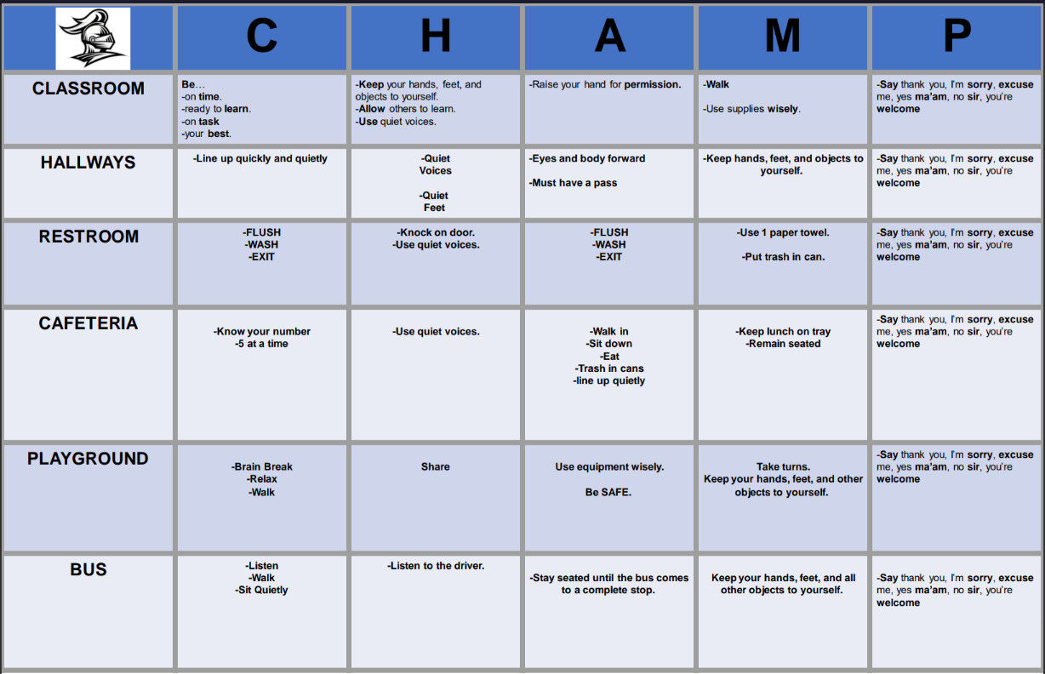

**Classroom Expectations:**

**Standards/ Rules**

1. Be Positive: Keep an awesome attitude.

2. Be Responsible: Come to class prepared with the necessary supplies and completed assignments; be honest.

3. Be Productive: Use class time efficiently, listen and follow all directions, remain on task.

4. Be Respectful: Always be kind to others in words and actions, keep your hands and feet to yourself, respect other people’s property and privacy.

5. Be Courteous: Use your manners, raise your hand, wait your turn, use appropriate voice levels at all times.

**Behavior Management Plan**

SpotLight is a positive behavior intervention and support system within Infinite Campus. Teachers manage both minor and positive classroom behavior, on a daily basis in SpotLight. Log into you Infinite Campus to track your child’s behavior.

**Disciplinary Action**

* Redirection
* Calming Corner (5 minutes to calm down and reflect)
* Contact Parent
* Referral to school counselor or social worker
* Time out on grade level (5-15 minutes)
* Time out on 1 off grade level (5-15 minutes)
* Disciplinary Referral

**Positive Reinforcements**

Jamestown PBIS reward system will be used for positive reinforcement.

* Knight Bucks
  + Students will have a two-week window to mark off at least 8 out of the 10 symbols. These symbols will be marked off as students exhibit positive behaviors that reflect our CHAMPS slogan as well as the school-wide behavior expectations. When students meet these requirements, they will receive a brag-tag necklace.
* Brag-Tag Necklace Fridays
  + Students will be able to wear their brag tags around the school.
* Monthly Popcorn or treat
  + At the end of the second earning window, the students who have earned at least two brag tags will receive popcorn or treats.
* PBIS Party
  + At the end of the semester, students who have at least 6 brag tags will be eligible to participate in the PBIS Party.
  + Throughout each window, the students will be able to receive additional rewards and be allowed to participate in classroom rewards as well.

**Important Information** include website here – with step-by-step instructions on accessing your teacher page.

Additional resources for my class can be found on my webpage:

Let’s work together so that we can have a successful year while increasing our knowledge in education!

Student Signature: ______________________________

Parent Signature: _______________________________ Date:________________