Grade Level: Dates: Oct 18 – Nov 15
School Information  School: Copeland Elementary  School Code: 060043  Teachers: Hall, Jackson, Yeldell, Rivera  Buffer: None | Transdisciplinary Theme: where we are in place and time  Segment of Theme: discoveries and explorations  Over Arching Concept: science and technology
Section 1: Overview
- Central Idea: Developments in science and technology affect individuals' lives
- Key Concepts: change, causation, connection
- Guiding Related Concepts: | - Lines of Inquiry: | - Teacher Questions (Guided Questions):
Technology  Invention  Microscope usage  Cell Theory  Timeline | One moment can alter a sequence of events throughout history  Location affects societies economy, culture, and science | DOK Level 3 & 4  What would the world look like without electricity?  How has electricity changed your life?  What inventions have humans created to make lives easier? (trails, planes, light, telephone, planting, domestication, Panama canal, microscope)  How are onions and humans similar and different? (before and after microscope usage)
- Prior Content Knowledge: | - Assessing the Lines of Inquiry:
Knowledge of living vs nonliving things  Some understanding of inventions such as electricity and what a microscope does  Students have prior experience researching both whole class and self-directed | How will you assess student’s understanding of the lines of inquiry?  -timeline piece (view summative content based assessments)
Section 2: What Are Our Target Goals?
- Concept Based Summative Assessment: | - Targeted Approaches to Learning (highlight 3): | - Targeted Learner Profile Attributes (highlight 2):
seesaw project- research, paragraph, timeline, presentation on how a single invention affects the lives of individuals | Social Skills, Research Skills, Communication Skills. Thinking Skills, Self-Management Skills | well-balanced, caring, principled, open-minded, risk taker, knowledgeable, communicator, reflective, thinker, inquirer
Section 3: What Assessments will be provided in this unit of inquiry?
- Pre-Assessments:  What assessment will be given at the beginning of the unit to inform current understanding | - Formative Content Based Assessments:  What assessments will be given to monitor student learning of content? | - Summative Content Based Assessments:  What assessments will be given for students to show mastery of unit content?
Pretests on science and social studies content as mandated by district- | Compare/contrast writing prompts  Sticky notes- parking lot questions as research continues  Content based common assessments on fridays  Group conferencing with teacher  Teacher observations during assignments  Utilizing a microscope activity | Invention study- informational paragraph with citations,  Compare/contrast plant and animal cells  Students will create timelines to show how their inventions have changed over time to demonstrate how a moment can alter a sequence of events.  - Science Fair Projects - RCSS Science and Engineering Fair honors RCSS student excellence in science, mathematics, technology, and engineering. Science and Engineering Fairs allow students the opportunity to research, create, and present through the development of independent research projects, guided by teachers and mentors.  - Science and Engineering Fair requires a varied range of essential life and career skills: reading, writing, math, critical thinking, ethics, communication and graphic arts.  November 9th - Topics and Purpose
Section 4: How will we Facilitate Learning?
- Provocation:  How will interest into this unit be sparked? | - Learning Experiences:  What activities/experiences will help facilitate the learning? | - Evidence of Differentiation:  How will the learning experiences be adjusted to different learning styles/abilities?
Begin with discussing electricity- if we didn't have electricity what would the world look like?  Electricity scavenger hunt  Blind compare/contrast of people and onions (Shrek meme- “I'm like an onion, I have many layers”) | - Start with whole class electricity invention study  -tune in-electricity scavenger hunt (provocation)  -find out- non electrical replacement, teacher led research into who invented the electrical objects that we found/use frequently (read alouds, youtube videos, myon books)  -Self-directed research-students will inquire by searching a topic from a preselected Myon folder for students to research on inventions that humans have created to make life easier utilizing the canvas project rubric for social studies GA (trails, planes, light, telephone, planting, domestication, Panama canal, microscope)  -students will write an informational paragraph with citations on their presentation, have students create a timeline to assess how their invention has changed things over the years, then record a narrated video of their paragraph and presentation on the invention that they researched, then share their video with peers via seesaw  Science Fair Research Paper – Students chose a topic for their Science Fair Project.  Students will research a topic for their Science Fair Project and submit the title and the purpose  Requirements:  - A Testable Question has 2 Part:  - Part 1: The part that is being tested. It is called the independent variable. This is the manipulated variable or the one that changes.  - Part 2: The part that is being observed or measured. It is the dependent variable, or the responding (measured) variable.  -Whole class- what do microscopes have to do with inventions? Why do we need to understand what things are made of?  -compare and contrast onions and people (blind) (provocation), then Use Microscope onion, cheek, compare and contrast, discuss first and last compare and contrast- are we more similar or different? What differences do you notice? | Myon enables differentiation- read aloud texts, varied reading levels, enabling research at students ability level  Seesaw- video presentations allow students to practice and become comfortable with presentation
- Learning Experiences in Specials:  How are Specials Courses able to connect to this unit? | - Local/National/Global Connections:  How can we connect the content to local/national/global issues? | - Student Action:  What learning experiences support potential student-initiated action?
Art  Students will be learning about the history of animation and create different types of early animation (I.e., flip books) as they begin a longer unit on Claymation. | Watch cnn10 to look out for new inventions/innovations  Cellular connection to pandemic, mRNA vaccines “talk to” the nucleus of animal cells  Science Fair Project Topics – Relevant to the life and interest of the students | -wanting to look at other things with the microscope beyond onion and animal cells  -diving deeper into human cells and what more components do  -independent research on inventions during self-directed research beyond the initial assigned inventions  Students will chose a topic for their Science Fair Project based on their own interests.
- Student Agency and Play:  What learning experiences provide students with voice, choice and ownership? What play opportunities will be provided by Kindergarten/Pre-K? hands on/STEAM for K-5? |  | - Resources:  Which resources will you and the students use? This may include people, places, technologies, learning spaces and physical materials.
Drawing cell cities  cell organelle text conversations  creating a 3d cell model  Predicting and drawing what they see in the microscope  Food model of the cells  Electricity scavenger hunt  Create your own invention (blueprint, discuss engineering design)  Draw a picture of your room without electricity (intro steampunk(?) Genre)  Science Fair Projects |  | Myon  Seesaw  Mrs. Shoemaker- media specialist  Microscopes, Slides  Internet- pictures of cells, videos  Food items for models of cells  Paper and pencil  Laptops  Ms. Perry- resource for IB guidance  http://www.sciencebuddies.org  Help with Science Fair Projects
Section 5: Reflection (Write the year, change font color for each year)
- Reflect on learning experiences:
Yeldell- Fall 2021-Students very much enjoyed learning about different inventions, and using the timeline was a great way to give students concrete models that they used throughout the discussions. I will continue implementing timelines as we teach history, as this group of students did significantly better with that aid. Students were also able to discuss how several inventors and processes over time lead to each product, as opposed to one person just discovering a whole new invention overnight. Students also enjoyed the microscope, and were able to identify cells, but the microscopes were not strong enough to present good models of animal cells, so that is an area that needed to be supplemented via the internet.

Jackson-2021- Students learned about the turn of century, where we how discussed inventors and their inventions made a difference in the development in the country. During this time, we observed how these same inventions allowed advancements in human lives in events like the cattle trail, Panama Canal. Students created inventions that they feel would be helpful to society during these times. When learning about cells students created their own cell and investigated different

Hall-2021- Students learned a lot when discussing inventions. They were very intrigued with how things were made and how they advanced from one person to another. They loved working with microscopes and learning more about the different types of cells. This was all new to them so they were very engaged in the different learning experiences during this unit.

- How were the tasks differentiated to meet different learning styles? |  | - How did the learning experiences and strategies we used throughout the unit help to develop and show students understanding of the central idea?
Yeldell- Fall 2021-Tasks were differentiated in a few ways. I had a table group for the microscope activities, my students who needed more teacher attention had a group with me for the microscope activity, whereas my students who were ready to try on their own had a group where they had to be a bit more responsible and independent. I also used Myon frequently to adjust to students reading levels. Durin the timeline activities, students were able to work in self-selected groups which ended up being relatively heterogeneous; many students were able to help one another when finding information. I did have a group of my lowest readers who I gave the times for the timeline in order, and then allowed them to fill in the rest of the information.  Hall-2021- Different students have different needs so some students conducted research independently while others were able to work in groups to help them be more successful with completing the tasks in this unit.  Jackson 2021- Depending on individual student needs, students were given a checklist to monitor their progress during writing techniques. Students were also given choice boards to give them an option to learn about different topics. For example, when learning about inventors, students had the choice to learn about the inventors in different ways. |  | Yeldell- Fall 2021-The timelines, discussions, and writing pieces that came out of the unit showed that the students understood the years of decisions and technology that went into each invention, as well as how deeply those inventions had affected their current day to day life. This was particularly evident in the student writings on seesaw about their day without electricity and their life without telephones.  Hall-2021- Students were able to discuss the different inventors and give background information on the inventions. They were also able to tell you different parts of a cell and the function of the part.  Jackson-2021- Students were able to understand the importance of inventions and how they made living better for others during that time. Students were able to understand the importance of cells and why they are needed.
- What learning experiences best supported students’ development and demonstration of the attributes of the learner profile and approaches to learning? |  | - How effective were the summative assessments in measuring student learning? What, if any, changes need to be made to the assessments?
Yeldell- Fall 2021-The learning experiences that best supported students development was the usage of the timelines, the writing activities about their life without __ technology, and using the microscopes. Students also enjoyed making an edible cell, but that was more so cumulative than it was developmental. The writing activities really encouraged students to be reflective thinkers, while the timeline allowed students to be knowledgeable.  Hall 2021- Working with the microscopes really helped students to understand cells and get a visual representation of what we were learning. It kept them interested and engaged throughout the lessons in this unit.  Jackson-2021- The learning experiences that best supported students’ development were timelines, choice boards, and the various writing activities. The students enjoyed working with microscopes as it help them understand the different parts of the cells |  | Yeldell- Fall 2021-The timelines were excellent, though I am not sure if they truly served as effective summative assessments. The informational paragraph was excellent as well, but I had some concern here as well as a summative. I think a better summative for next year would be to have students create analogies for their cells with a complete write up and present those analogies. For the invention component, a more traditional quiz may have been helpful, as well as perhaps a reflection of the timelines and what had been learned. In my class at least, the timelines had a lot of “we do” components so I wasn’t able to use those to assess as individually as I would have liked.  Jackson- 2021- The summative assessment was very effective for students and was agreat tool to sum p the unit. The informational writing was a challenge for most students to complete and many needed to use a checklist to make sure all parts were completed.  Hall 2021- They were very effective. I was able to gauge student learning and understanding with each assessment.
- What student-initiated inquiries (questions) arose from this unit of inquiry? |  | - What student action arose from this unit of inquiry?
Yeldell- Fall 2021-Students were curious as to what other things would look like under the microscope- such as spit, hair, skin (of different animals and objects), and more. Students were also curious as to what nonliving things would look like under the microscope since cells were particular to living things. On the invention side of things, students were curious as to how electricity was discovered, what things would look like without it, and what other natural forces we haven’t discovered yet (such as harnessing light?!?).  Jackson-2021- Students had many of questions such as: What would happen if cells stop producing? What if a cell is missing a part in it? Will it create more cells that are not correct? How did people look at cells before the microscope was invented?  Hall 2021- Students wanted to know the differences between the cells. They wanted to know how the microscope worked? Who invented it? Students wanted to know how long it took to make the inventions. They wanted to know what made them want to invent different things. |  | Hall 2021- Students brought in their own microscopes to help with our cell exploration.  Jackson- 2021- Students designed informational posters, tiktoks, and PowerPoints to inform others about the importance of cells.
- Any additional notes or changes that need to be considered next year?
Yeldell- Fall 2021-I mentioned changes that could be made to summative assessments in number 5.
Art:
Students have not completed their claymation projects yet however, students are extremely engaged and are loving this activity.
Section 6: Picture Evidence
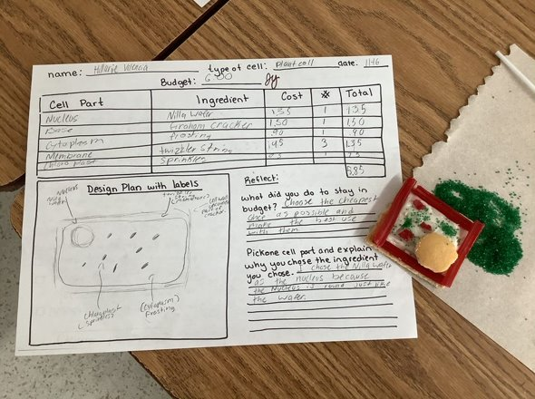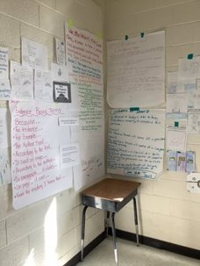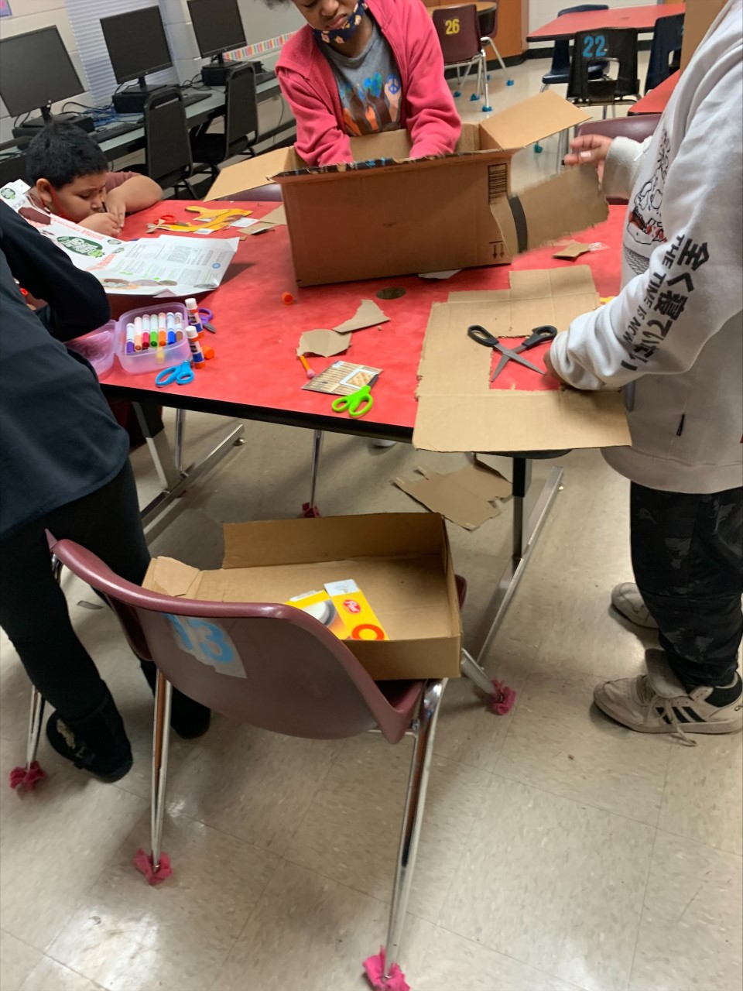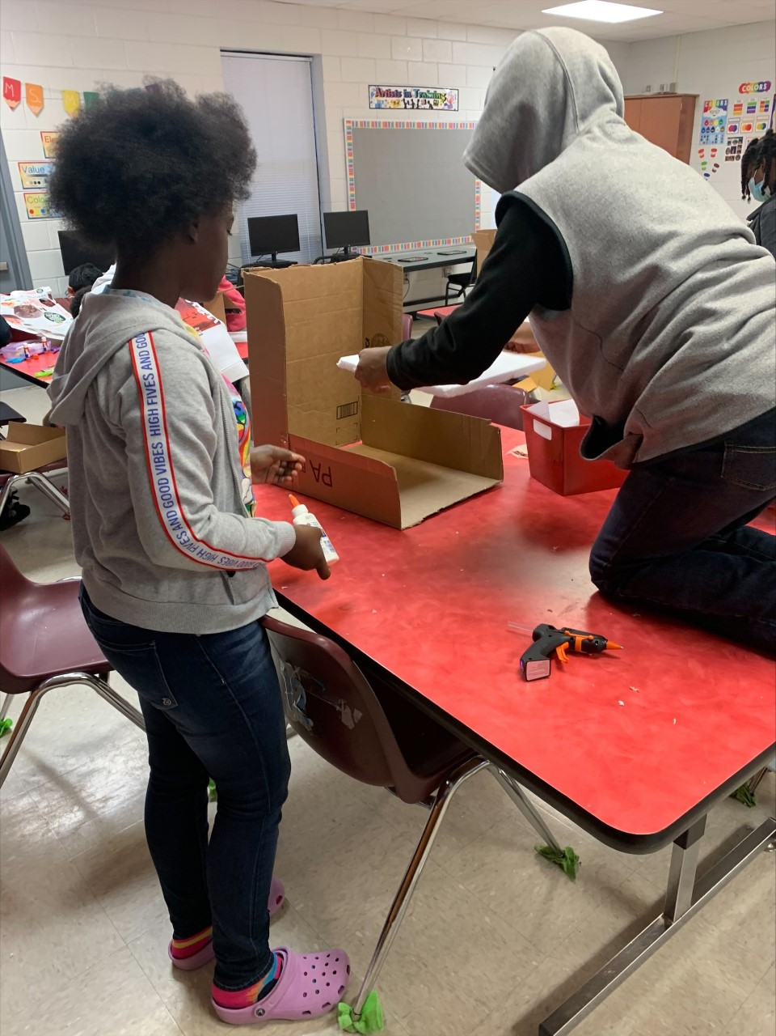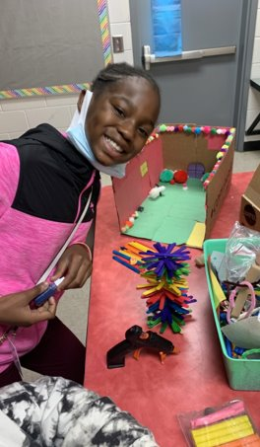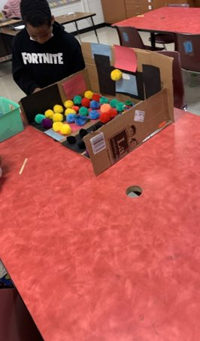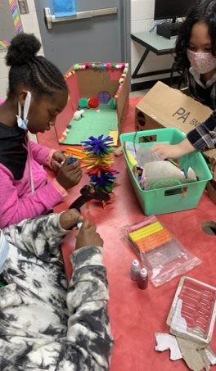
**Scroll Down for Unit Standards**

Unit Standards:

ELA:

Math:

Science:

Social Studies:

