Welcome to Mrs. Daniels’ Ballet 1, Ballet 2, and Beginner Men’s Dance classes!
- Students must have their required attire NO LATER THAN WEDNESDAY, SEPTEMBER 3rd.
- Please email me at danieco@richmond.k12.ga if you have any questions or concerns.
- You are encouraged to purchase your supplies in ANY brand and at ANY store of your choice. I am providing the following links for some items I found on Amazon that may be helpful to you. You do not need to order these exact items if you already own similar items, or you find them at another store or price point that suits you better. If you’d like to purchase items (especially shoes) at a local store, please go to:
“Tutus and Dance Shoes”
139 Davis Rd, Suite D Augusta, GA 30907
Monday-Friday 10:00-6:00 Saturday 10:00-3:00 Sunday CLOSED
(706) 305-1850
info@tutusanddanceshoes.com
Ballet 1 and Ballet 2 Girls
ITEM | PHOTO | AMAZON LINK
OPTIONAL (but strongly recommended for both girls and boys):  - Delicate bag to keep items contained traveling to/from home/school.  - It helps keep items together inside the student’s backpack and reduces lost items during transit. | 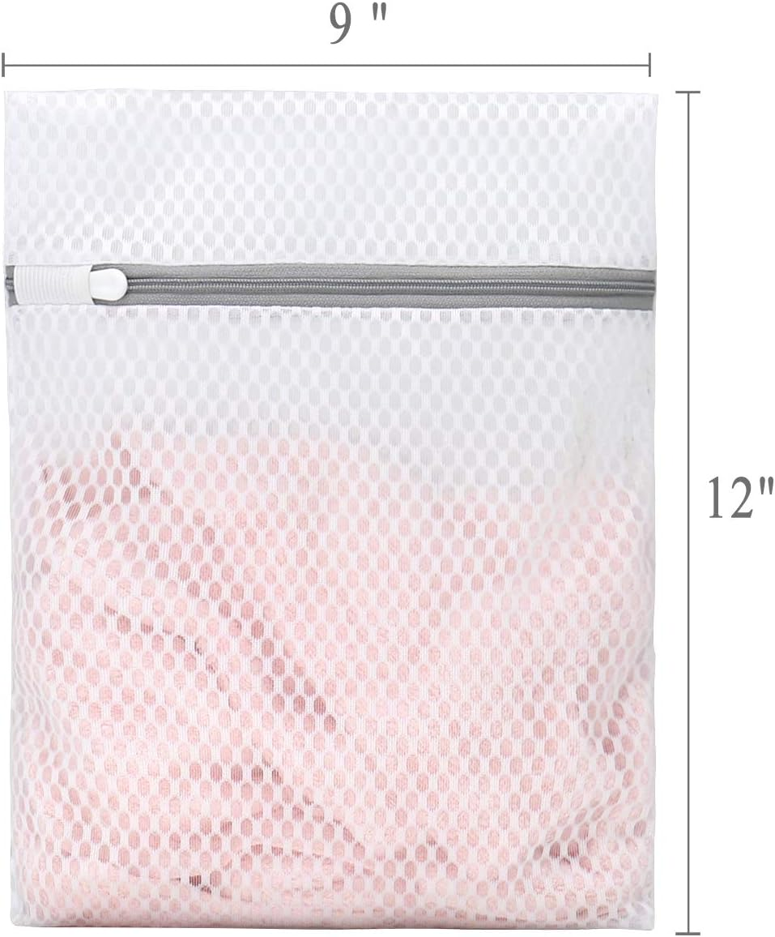 | https://www.amazon.com/Durable-Honeycomb-Mesh-Laundry-Delicates/dp/B08FSVQ24P/ref=sr_1_5?crid=276WYPAMT3XXM&dib=eyJ2IjoiMSJ9.Sp5r85bE62KahAqycKYJCyheKEHvSL0f_yPwczb-WErBsKFuGvb6Nry_JiKP-ArRAvVdSWy0xpGNMRd9d_h62yBBBy3R2oaOUc_vZm9weik5IbZ5z0mhmwhvEdAC8iSZuAYvGHYcXnwTdNNBAnKn7KpSagBvdmKCtexKE4rmHFrIDhObGih_eEA2X-ImHfVpBAZqiODw3ORIicr-ILqnbuQPTCJNeKJNGJ6rhGPWH22l8yOsCd6nHCbMDU5VucSfkBh9NUexlIM9E8URINjpeQ7V7VZmyQUHWuJVQ2WEAtc.lzg09Bm_L1-ewP0WGO5HuayTw3I333cxGIB_KloXr_Y&dib_tag=se&keywords=small+delicate+laundry+bag&qid=1753544360&sprefix=small+delicate+laundry+bag%2Caps%2C93&sr=8-5
Girls' basic black leotard | 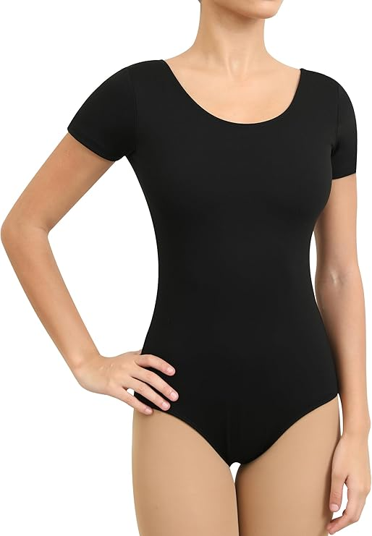 | https://www.amazon.com/dp/B0CD24G1PB/ref=sspa_dk_detail_3?pd_rd_i=B0CD2515D1&pd_rd_w=Lc4g3&content-id=amzn1.sym.bbb3fb5e-28ad-4062-a3ba-1f7b9f2e4371&pf_rd_p=bbb3fb5e-28ad-4062-a3ba-1f7b9f2e4371&pf_rd_r=B1CRN8SX4TWEQVN9EXVS&pd_rd_wg=VdauZ&pd_rd_r=35fa0ceb-a1c1-4ef9-ada3-274424a310ec&sp_csd=d2lkZ2V0TmFtZT1zcF9kZXRhaWxfdGhlbWF0aWM&th=1&psc=1
Girls' basic black leggings | 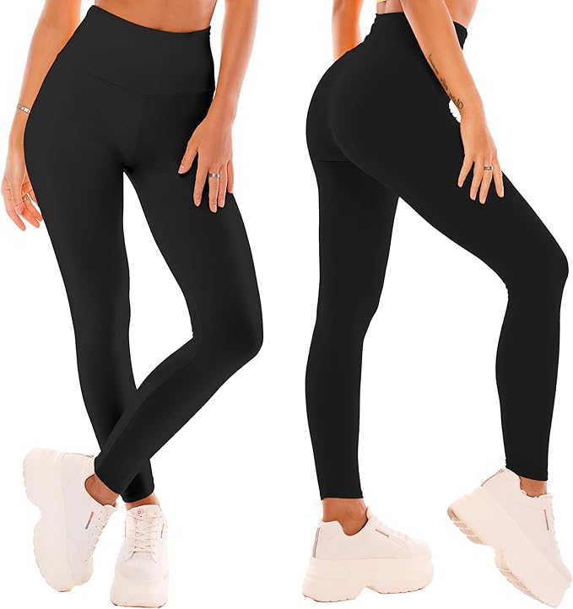 | https://www.amazon.com/SINOPHANT-High-Waisted-Leggings-Women/dp/B0BVF476TZ/ref=sr_1_1?crid=2MZC9EILWCYTX&dib=eyJ2IjoiMSJ9.JnsB0RkV4F2uug2R1ZlABix3daccKcFuS0tcPbD9QpOUc_WWknxDj1Z8eFXHqaUjPG0g8Yg3-I8twFzZi-Zad0uIgtWKCR2t1ya8y8M7A0pYrDTYruiTR99MwUG7X4yojWPzM1MpYG-Ja6_9WbPJvOLL2e-1HsMUDlCHxdn9YycpVB313MhOIcGgRIS4S3SdkoXYfzN0MMAycrQ7tM_i1rAM4ggiKTh_RvvJgDjsr1g.q7quUx_h5tTOPP-YiP0ZEawKCzn0gnQnQ8earb8KkC8&dib_tag=se&keywords=black+leggings+women&qid=1753539420&sprefix=black+leggings%2Caps%2C124&sr=8-1
Girls’ Ballet shoes  (Please choose “ballet pink”, “sand”, or “tan”) | 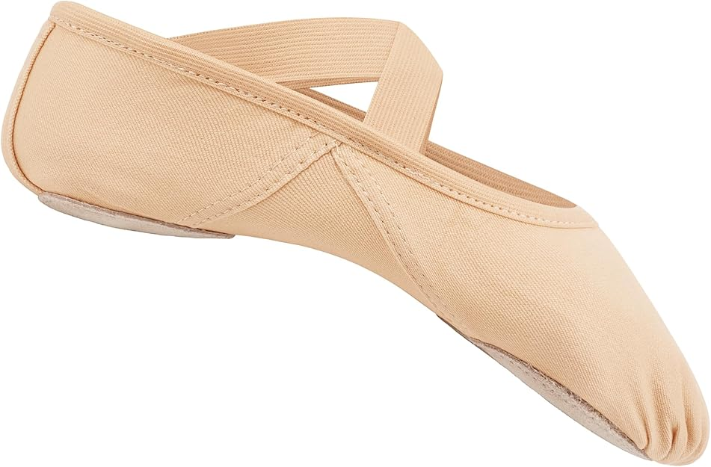 | https://www.amazon.com/Stelle-Ballet-Stretch-Slipper-Non-Slip/dp/B0F639HGMM/ref=sr_1_4?crid=14YWMC3T18P7C&dib=eyJ2IjoiMSJ9.jrMNVluS_lDgVZxn6vzYgNyv417LZby3ZUzTY_ic1GL111LA_GpSblQRlaKwaJPiiwBkiJ82nyF9WdfnsOtKWrkU5Rh6yOQkxNkyfgwUxejEs5rW-gdAM36TgwaQaV3dGBZC4CqPYYHxYihYRkIO64NXfTksl42RZrQWjbNSPDnjTr5CQFyO9ZkvJPd7ShF2kEYTB5c_rzAyQ8pI_t2xPhvJdLKa2YTtx80eaRhQDTA.gOoTNQ35vuN2s2S-hb-A-0JrhGqxevMI4Bsb-UgR5k0&dib_tag=se&keywords=canvas%2Bballet%2Bshoes&qid=1753539724&sprefix=canvas%2Bballet%2Bshoes%2Caps%2C119&sr=8-4&th=1&psc=1
Beginner Men’s Dance and Ballet 2 Boys
ITEM | PHOTO | AMAZON LINK
OPTIONAL (but strongly recommended for both girls and boys):  - Delicate bag to keep items contained traveling to/from home/school.  - It helps keep items together inside the student’s backpack and reduces lost items during transit. |  | https://www.amazon.com/Durable-Honeycomb-Mesh-Laundry-Delicates/dp/B08FSVQ24P/ref=sr_1_5?crid=276WYPAMT3XXM&dib=eyJ2IjoiMSJ9.Sp5r85bE62KahAqycKYJCyheKEHvSL0f_yPwczb-WErBsKFuGvb6Nry_JiKP-ArRAvVdSWy0xpGNMRd9d_h62yBBBy3R2oaOUc_vZm9weik5IbZ5z0mhmwhvEdAC8iSZuAYvGHYcXnwTdNNBAnKn7KpSagBvdmKCtexKE4rmHFrIDhObGih_eEA2X-ImHfVpBAZqiODw3ORIicr-ILqnbuQPTCJNeKJNGJ6rhGPWH22l8yOsCd6nHCbMDU5VucSfkBh9NUexlIM9E8URINjpeQ7V7VZmyQUHWuJVQ2WEAtc.lzg09Bm_L1-ewP0WGO5HuayTw3I333cxGIB_KloXr_Y&dib_tag=se&keywords=small+delicate+laundry+bag&qid=1753544360&sprefix=small+delicate+laundry+bag%2Caps%2C93&sr=8-5
Boys’ Basic Black Joggers | 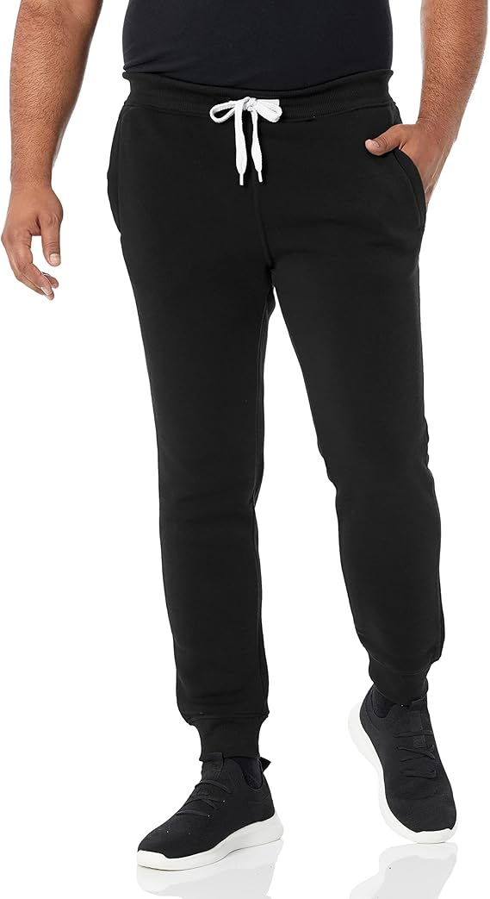 | https://www.amazon.com/Southpole-Active-Basic-Jogger-Fleece/dp/B00LGRXL2K/ref=sr_1_7?crid=2TD78HRSZ01G8&dib=eyJ2IjoiMSJ9.U6RoJsCqrf-RId061dmVjnvOi4aMyd0qfGY5G9m6VyJ6ELpcIllJl5_oogaluaWxBKm7o4vEB78nDFJCYgECPDGXohw_SXgY26-mSJJvJeZu_NcNQ5U71GLkb-7NJ4s4ezPrxBBKmKWL4CTzNmoKbfGT5yJPqJTT-Ix1nawOcETfJPu1FIAtqsj4VBlvyiTo4zLrTvHIPbGm0saCY2WNnyE4twLaty8NKhtakF_SCyZkCUk1_nQqmAYHrlqJdhTVPdIocwpda7UCGw1ytsG9juXxWaKTBAn_P04TGKtdnEI.wWxcp0zpQU4AmAwdvHFYf9m__jZvqGZkTa0G6aRmtQE&dib_tag=se&keywords=mens%2Bjoggers&qid=1753539539&sprefix=mens%2Bjoggers%2Caps%2C115&sr=8-7&th=1&psc=1
Boys’ Basic Black t-shirt | 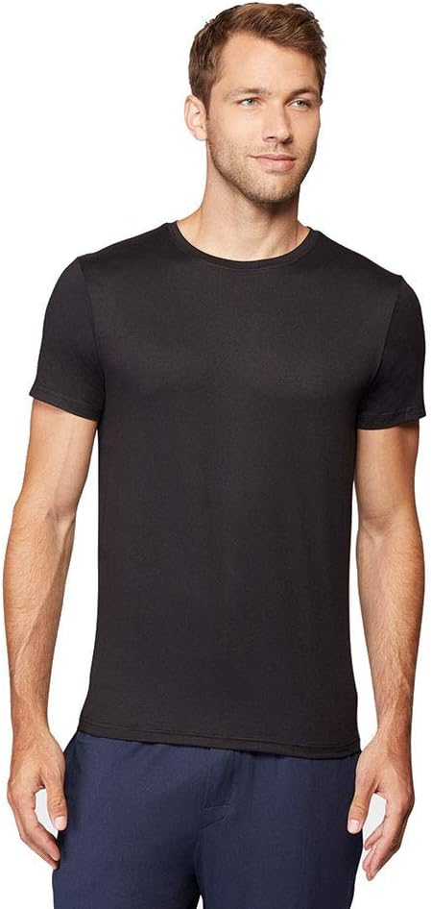 | https://www.amazon.com/Degrees-Quick-Active-Basic-T-Shirt/dp/B07HZLLGQF/ref=sxts_b2b_ccp_search_w_op?content-id=amzn1.sym.210cd1ea-e44d-496c-802a-e2b84397e3ce%3Aamzn1.sym.210cd1ea-e44d-496c-802a-e2b84397e3ce&crid=3AHHBBF71YTHC&cv_ct_cx=mens+black+dry+fit+shirts&keywords=mens+black+dry+fit+shirts&pd_rd_i=B07HZLLGQF&pd_rd_r=c3b758ce-571e-40f1-9a3a-f405d159e193&pd_rd_w=pa2Mx&pd_rd_wg=D6WbH&pf_rd_p=210cd1ea-e44d-496c-802a-e2b84397e3ce&pf_rd_r=MN13GQV8PJMXV6BJZBGM&qid=1753539647&sbo=RZvfv%2F%2FHxDF%2BO5021pAnSA%3D%3D&sprefix=mens+black+dry+%2Caps%2C119&sr=1-4-d27bdacb-ad14-3372-97fb-5f5070035007
Boys’ Dance Shoes  (please choose “black”) | 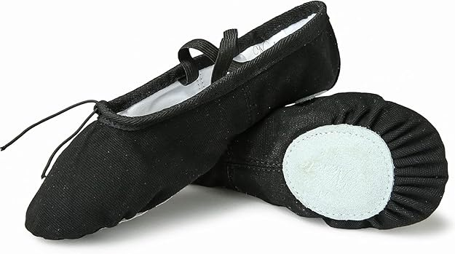 | https://www.amazon.com/Nexete-Ballet-Gymnastics-Split-Sole-Slipper/dp/B072MGBJDS/ref=sr_1_2?crid=39LSCIMGUUY2U&dib=eyJ2IjoiMSJ9.Ac0BJfeG_CUJuLEi75K9tR4spSWat_c3LrRPR0o46qBxtpqmMGrs0C_FRhOb0aCkGgLf9fbBJKHTdWnKOrd1xTavf68tJqiEelJyjp_K-mulxM-9b_8zf2GuD6Al7ehhjlxzN1aVL3RQ3Q66xrxtpHiW6C-bQhCnQx8PA4BavGQ63wJpO0G3hDvsuAqQ37Px02s-n4ROn6E02ud6RoSMC_ceYmPcWafHbhgghfdCw1U.nl988pvBhTcmViYSiBMilUoBzRIjfg073vwX04rvdtg&dib_tag=se&keywords=canvas%2Bballet%2Bshoes%2Bmen%2Bfull%2Bsole&qid=1753539904&sprefix=canvas%2Bballet%2Bshoes%2Bmen%2Bfull%2Bsole%2Caps%2C89&sr=8-2&th=1&psc=1

Reminder:
- Students must have their required attire NO LATER THAN WEDNESDAY, SEPTEMBER 3rd.
- Please email me at danieco@richmond.k12.ga if you have any questions or concerns.

