Grade Level: Second Grade Dates :October 4- November 12
School Information  School: Copeland Elementary  School Code: 060043  Teachers: Brown, Echols, Huggins, Timmons, and Ginn  Buffer: November 15-November 19 | Transdisciplinary Theme: How We Organize Ourselves  Segment of Theme: Human Made Systems  Over Arching Concept: Leadership
Section 1: Overview
- Central Idea : A community functions and changes to meet the needs of its members.

- Key Concepts: Function, Change and Connection
- Guiding Related Concepts: | - Lines of Inquiry: | - Teacher Questions (Guided Questions):
Leadership, Community and Structure | Rules and laws connect the members of a community.  The executive branch affects change in a community  The function of money, goods, and services in a community | DOK Level 3 & 4 ( 4-6 Questions)  How do laws and rules impact people?  How does government impact our lives?  How do the choices you make with money impact your life?  Who makes choices about us?  How are people elected into office?  How do the leaders of the executive branch of government enforce laws?
- Prior Content Knowledge: | - Assessing the Lines of Inquiry:
Students will need to know the definition of community.  Students will need to know what it means to be a member of a community  Students will need to know what it means to be organized  Students will need to be familiar with the term government. | How will you assess student’s understanding of the lines of inquiry?  Students can explain how elected officials create change in America.  Students can give examples and explain goods and services used within the school, community, country, and globally  Can students explain and compare the function of the different parts of the executive branch.  - Student Reflections  - Mock Election  - Gallery Walks
Section 2: What Are Our Target Goals?
- Concept Based Summative Assessment: | - Targeted Approaches to Learning (highlight 3): | - Targeted Learner Profile Attributes (highlight 2):
Students will brainstorm ideas for a rule that should be added or changed within the current school rules. The class will vote on a few of the best options. The class will then decide on a way to present their proposal to Dr. Taylor and Ms. Parks.  Our Classroom Economy- The students will create their own economy within the classroom. This economy can be implemented for this unit only or the entire year. Jobs can be appointed, elected (hold a classroom election for mayor), or students can apply for jobs within the classroom. Jobs can include mayor, tutors, police officers, bankers, sanitation supervisor, supply manager, etc. “Employees” will be paid but will have to give a portion back for classroom taxes. Students can make products to “sell” but must also pay classroom taxes. Use this opportunity to explain that the taxes pay for jobs (police officer, mayor, teacher, etc.). Students can use their earnings to purchase items from each other, school supplies, or even a class store (treasure box, homework passes, lunch with the teacher, etc.). | Social Skills, Research Skills, Communication Skills. Thinking Skills, Self-Management Skills | well-balanced, caring, principled, open-minded, risk taker, knowledgeable, communicator, reflective, thinker, inquirer
Section 3: What Assessments will be provided in this unit of inquiry?
- Pre-Assessments:  What assessment will be given at the beginning of the unit to inform current understanding | - Formative Content Based Assessments:  What assessments will be given to monitor student learning of content? | - Summative Content Based Assessments:  What assessments will be given for students to show mastery of unit content?
KWL Charts  Discussion questions  SeeSaw - Activities on adjectives and verbs. Activities on Punctation and Capitalization in sentences.  SeeSaw( Students will write a Narrative about themselves  Pre Test I-Ready- Reading, Math | KWL Charts  Mock Election - Class Election  Gallery Walks  SeeSaw Reflections - Written and Recorded | Benchmark, Studies Weekly SS tests  Post Test i-Ready – Reading , Math  Post Test( Writing)- SeeSaw( Students will write a narrative about themselves and a famous Georgian.  Fundations Unit Test
Section 4: How will we Facilitate Learning?
- Provocation:  How will interest into this unit be sparked? | - Learning Experiences:  What activities/experiences will help facilitate the learning? | - Evidence of Differentiation:  How will the learning experiences be adjusted to different learning styles/abilities?
Elections and Voting- Begin by posing a question and allowing students the opportunity to vote. When laying out the question you can give students a pretend new school policy. To engage students, you can make both choices undesirable but tell students that they still have to vote. Allow students to vote and then announce a “winner.” Lead a class discussion. How did they vote and why? Who was the winner of the election? How was the winner decided? Does your choice always match the vote of others? What happens when you disagree with the results of the vote?  *Although elections and voting are not in the standards, students may need to understand the concept of voting and elections to understand the content related to the elected officials they will be studying. | Weekly Read Alouds:  - A Dream Playground  - A Duck for President  - Grace for President  - Marvelous Cornelius  - Vote  - House of Dirty 3rd Street  Week 1: SS2CG1 Define the concept of government and the need for rules and laws.  - What is a leader? What makes a good leader? Why are leaders important? Have students create a list to share with the class. Allow students time to create their lists and call students together to share their thinking. Chart the group responses. What did the lists have in common?  - Social Studies Weekly “Our Government”  Week 2: SS2CG2 Identify the following elected officials of the executive branch and where they work: a. President (leader of our nation) and Washington, D.C. – White House b. Governor (leader of our state) and Atlanta, GA – State Capitol Building c. Mayor (leader of a city) and city hall  - Social Studies Weekly “The President”  - Elected Officials Sorting- Students will analyze images related to elected officials. *Add images of the current President, current Governor, and your local Mayor and City Hall. Have students study each image. What do they see? What do they notice? Why do they think the image is important? Have students write in their interactive notebooks. Have students divide a separate sheet of paper in to three sections – Mayor, Governor, and President. Students will cut out each picture and paste it in the correct section. *Add images of the current President, current Governor, and your local Mayor and City Hall. Provide a word bank and students can add captions to each picture.  - White house Virtual Tour-  https://www.360virtualtour.co/portfolio/the-white-house-google-virtual-tour/  - GA State Capitol Virtual Tour-  https://georgiavirtualtours.com/georgia-state-capitol/#tour  - Elected Officials Flip Book- Students will create a flip book to organize information about the Mayor, Governor, and President.  Week 3:  - Social Studies Weekly “Presidents, Governors, Mayors”  - Heads of State Project- Students will choose one elected official and create a poster. It should include a picture of the official, his/her name, job title, where he/she works (building and city) and at least two responsibilities of the official.  Week 4:  - SS2E2 Identify some ways in which goods and services are allocated (such as: price, majority rule, contests, force, sharing, lottery, authority, first-come-first-served, and personal characteristics).  - Goods vs. Services- Students will work in groups or pairs for this activity. Each group will divide a paper into two sections – goods and services. Students will provide at least five goods and services by cutting from magazines and newspapers or drawing pictures. Each group will choose one good and one service to write about. Students will answer the following questions on the attached worksheet: Which good did you choose from your chart? Which service did you choose? How are the good and service different? How are they alike? How is the good obtained? How is the service obtained?  - Goods and Services: Let’s Make a Deal  https://www.education.com/lesson-plan/lets-make-a-deal/  - Social Studies Weekly “Goods and Services”  Week 5:  - Social Studies Weekly “Economic Choices”  - Student Reflection Piece  - Seedfolks – One act play performed by the middle school drama team from Davidson’s Fine Arts Nov. 17th - 9AM | The learning experiences will be adjusted by grouping students together based on their learning styles and abilities. If there are students that have sped coming into the class, then sped will assist with teachings.  Students will also be grouped by learning styles and skills. Each learning experience will cater to each leaning style i.e. if a student learns better by visual we will have video.  Students will work in Myon based on their Lexile levels  Readworks based on Lexilie levels  .  SeeSaw-Assignments on IB topic( How we organize ourselves), or foundational, speaking and listening skills.
- Learning Experiences in Specials:  How are Specials Courses able to connect to this unit? | - Local/National/Global Connections:  How can we connect the content to local/national/global issues? | - Student Action:  What learning experiences support potential student-initiated action?
Art  In art, we will focus on some of the crafts created by other cultures and utilized in various celebrations and traditions. Students will learn about Dia de Los Muertos and the history of crafts and symbolism relating to this holiday celebration.  Spanish  We will be focus on how the different symbols in “The Day of the Death celebration” represents a famous Mexican celebration. | Virtual Tour of the White house and the GA State Capitol Building.  School functioning as a community  Seedfolks – One act play performed by the middle school drama team from Davidson’s Fine Arts Nov. 17th – 9AM  The mayor of Augusta will come to visit. | Students lead out with questions about voting and branches of government.  Mock Election - Elect a Class President  Classroom Economy Project
- Student Agency and Play:  What learning experiences provide students with voice, choice and ownership? What play opportunities will be provided by Kindergarten/Pre-K? hands on/STEAM for K-5? |  | - Resources:  Which resources will you and the students use? This may include people, places, technologies, learning spaces and physical materials.
Doing assignments that require students to work with others to learn the importance of working and functioning as a classroom community.  Election guidelines – Students design the guidelines for the class elections.  Mock Election – Students create a campaign for class president, present their campaign and vote. Each class sends their winner for a grade level election. The students vote on the class president for the grade level. |  | https://lor2.gadoe.org/gadoe/file/f9ddcd80-8956-474c-89d5-1974f25a11d5/1/Social-Studies-2nd-Grade-Unit-2-Sample-Unit.pdf  Social Studies Weekly  YouTube  Myon  SeeSaw  IReady  Photos used for Gallery Walks  Virtual Tour of the Whitehouse  Visuals – images of former Presidents  Magazines  Newspapers  Weekly Read Aloud:  A Dream Playground  A Duck for President  Grace for President  Marvelous Cornelius  Vote  House of Dirty 3rd Street  Myon – What is a President?  Myon – What is a Mayor?
Section 5: Reflection (Write the year, change font color for each year)
- Reflect on learning experiences:
Ginn: Students really loved completing Gallery Walks and Writing what they would do if they were President. They also loved taking part in the mock election and creating their own goods and services.
Echols Good variety of activities. Students enjoyed presenting projects
Brown: My students really enjoyed learning about the executive branch and completing the KWL charts about each important part. My students also took a lot from the mock election. They were so intrigued that a lot of my students did further research on the city council in our town.
Timmons: Students were interested in learning about government leaders and what all they did as a leader. They were able to compare the duties of the mayor, governor, and president. Students were also interested in learning about producers and consumers, and how businesses work when distributing goods and services
- How were the tasks differentiated to meet different learning styles? |  | - How did the learning experiences and strategies we used throughout the unit help to develop and show students understanding of the central idea?
Ginn: Some students drew about being President, while others wrote a paragraph. If students needed visuals to understand what to write, they had that as well.  Echols Writing about being President was a fun presentation!  Brown: As we were learning about each part of the branch (President, Governor, Mayor) I had my higher level learners create booklets to identify the responsibilities of each part and I had my other learners create a circle map and pictures to identify the roles of each part.  Timmons: Students were given an assignment to write what they believed made a good president. Students who have trouble writing were able to draw pictures to show what they make a good president. |  | Ginn - I believe that the hands on activities and the collaborations done by the students help them understand the meaning of the central idea.  Echols DI instruction with range of levels was successful  Timmons: Students were able to relate the central idea about community functions changing to the our leaders making rules for the us to wear mask to stay safe.  Brown: The learning experiences helped because our students were able to do engaging activities that best helped them understand the central idea.
- What learning experiences best supported students’ development and demonstration of the attributes of the learner profile and approaches to learning? |  | - How effective were the summative assessments in measuring student learning? What, if any, changes need to be made to the assessments?
Ginn -Students given speeches and participating in the mock election helped the students developed an understanding in leadership. Students also creating goods and services in groups were important as well to make sure of their understanding.  Brown: The mock election was a great way and also the classroom market.  Timmons: The mock election allow students to be apart of the election process. Students were able to running for class president and campaign to other students. Students who were voting were able to listen to issues that they felt were important to them and look for them in the candidate they voted for. They also were excited about creating businesses where they are able to sell goods and services. |  | Ginn - The writing assignments help students become more reflective in understanding citizenship. The students do have more to complete on next week, so I will update. The goods and services projects displayed the understanding of scarcity and the difference between both good and services.  Timmons: The summative assessments were great for giving hands on experience with goods and services and becoming a producer and consumer in the classroom taught them about having goods that people wanted to buy.  Brown: The studies weekly assessments were able to assess the knowledge our students grasped over the executive branch and goods & services. The summative assessment was also informative on measuring the students' knowledge on the different topics.
- What student-initiated inquiries (questions) arose from this unit of inquiry? |  | - What student action arose from this unit of inquiry?
Ginn- Students really wanted to understand the responsibility of being a president, governor, and mayor and the impact that would be made.  Timmons: Students were interested in chain on command between president, governor and mayor and which one had more power.  Brown: I had students that asked who helps the mayor make laws in our city? Do the governor and mayor talk to one another? My students were also interested in do the mayor's decisions effect the governor and president. |  | Ginn- Students learned the importance of leadership and also the importance of organization.  Echols- Students gained knowledge of how government works  Timmons : Students were able to understand how our community changes when making sure its member needs were meet.  Brown: I had students asking to research the different members of the city council in our city. I had some students that asked to write a letter to the mayor about getting more parks in the city.
- Any additional notes or changes that need to be considered next year?
Spanish:
Ss loved the Spanish song about “The Day of the Death” and they were engaged by making an altar with the main symbols of this Mexican celebration.

Section 6: Picture Evidence
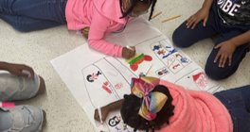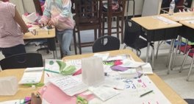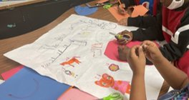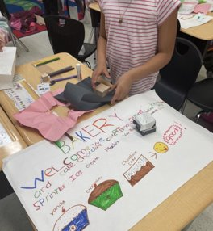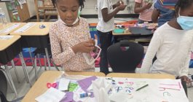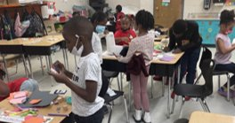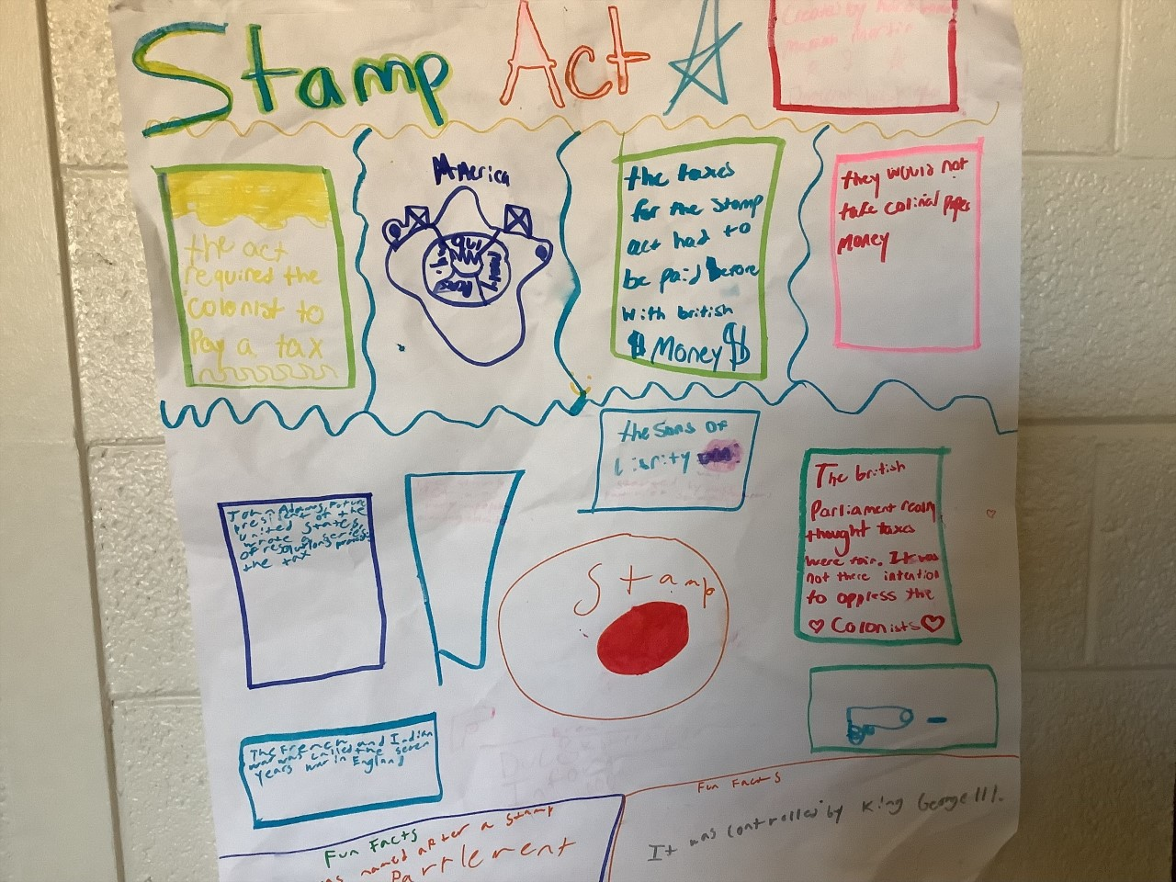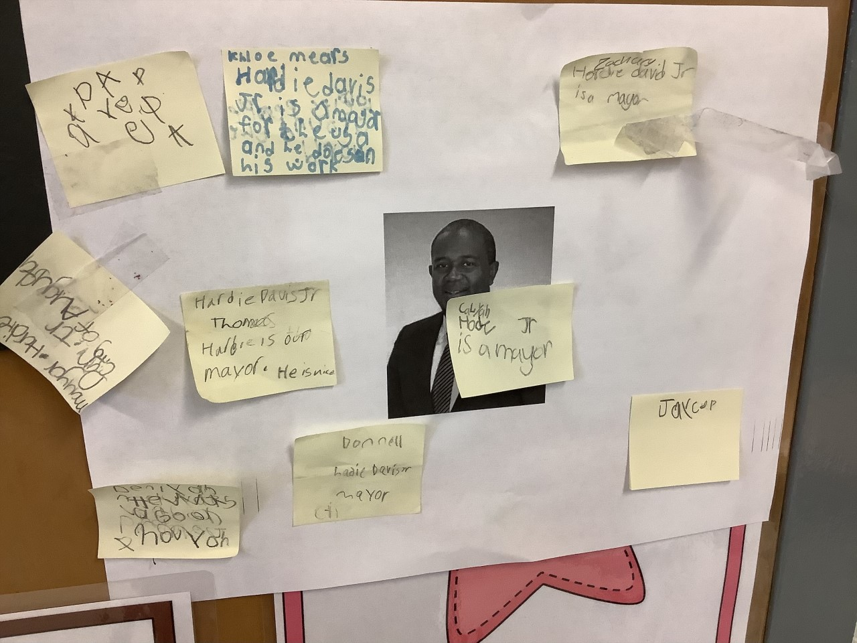
**Scroll Down for Unit Standards**

Unit Standards:

ELA:

Math:

Science:

Social Studies:

