ARC Week at Glance
Subject: ELA Course: American Literature Date: 8/12/2024
Standard(s): RL.11.3, RL.11-12.1
Assessment(s): ☒ Quiz ☐ Unit Test ☐ Project ☐ Lab ☐ None
 | Learning Target  (I am learning about…) | Success Criteria  (I can….) | Opening  (5 min) | Stations/Whole Group  (20 - 25 mins) | Closing  (5 - 10 mins) | Literacy Tasks/Focus
 |  |  | (Include at least one/two formatives*in any part of the lesson as needed)
Monday | I am learning how to use various texts (documents) to help formulate and support an opinion. | I can write a short paragraph explaining how to balance pride in American accomplishments with a realistic awareness of America’s flaws—using information found in various texts. | Quick Write: In what ways can we be proud to be an American? In what ways, can we admit America is flawed? | The teacher will demonstrate how to rotate to each “text station” and how to answer the prompt questions.  Together we will rotate through the stations, discussing the texts and answering prompts, as the teacher supports. | The students will write an individual response to the main prompt: How do we balance pride in American accomplishments with a realistic awareness of America’s flaws? | Reading, annotation, discussion, writing
Tuesday | I am learning how to utilize a variety of grade-level appropriate strategies to determine the meaning of words and phrases. | I can identify word meaning. | Introduction to stations/rotations  Modeling stations | Station #1: Vocabulary  Station #2: Geography  Station #3: History | Exit Ticket:  Who were the conquistadors and what was their relationship with the early Americans? | Close reading, diagrams
Wednesday | I am learning how to explain how specific events interact and develop over the course of the text. | I can practice close and critical reading. | 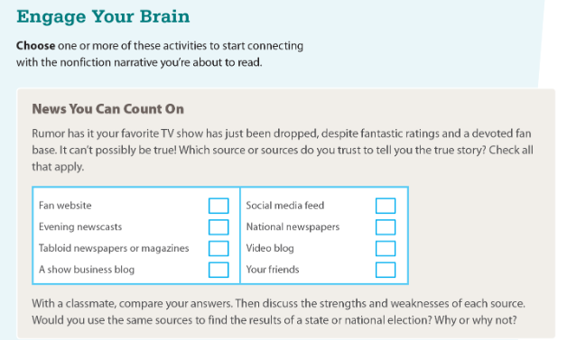 | Guided Reading: A Desperate Trek Across America  p. 43-48 | 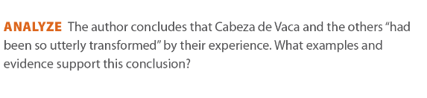 | Click or tap here to enter text.
Thursday | I am learning how to analyze a complex set of ideas or sequence of events. | I can readily distinguish between important facts or supporting details and extraneous or misleading information. | With a partner, write a list of questions members of the Spanish court might have asked Cabeza de Vaca about the New World. | 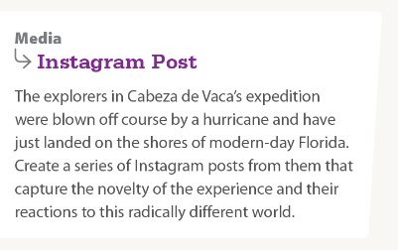 | Assessment Practice: p. 49 | Writing
Friday |  |  |  |  | Quiz: RI3/RI4
*☒ Exit Ticket/Final Stretch Check ☐ Electronic Tools ☐ Dry Erase Boards – quick checks ☒ Turn & Talk Discussion (verbal responses) ☐ Teacher Observation – document Clipboard
☒ Quick Write/Draw ☒ Annotation ☐ Extended Writing ☐ Socratic Seminar ☐ Jigsaw ☒ Thinking Maps ☐ Worked Examples ☐ Other :___________

