Standard: 10.T.T.4 (a&b), 10.T.C.1 (b&c), 10.T.C.2 (c&d), 10.T.SS.1 (a&b), 10.T.SS.2 (a&b)

Assessment: ☐ Quiz ☐ Unit Test ☐ Project ☐ Lab ☐ None
 | Pre-Teaching    Learning Target    Success Criteria 1  Success Criteria 2 | Activation of Learning  (5 min) | Focused Instruction  (10 min)  *I DO | Guided Instruction  (10 min)  *WE DO | Collaborative  Learning  (10 min)  *Y’ALL DO | Independent Learning  (10 min)  *YOU DO | Closing  (5 min)
 |  | - Do Now  - Quick Write*  - Think/Pair/Share  - Polls  - Notice/Wonder  - Number Talks  - Engaging Video  - Open-Ended Question | - Think Aloud  - Visuals  - Demonstration  - Analogies*  - Worked Examples  - Nearpod Activity  - Mnemonic Devices* | - Socratic Seminar *  - Call/Response  - Probing Questions  - Graphic Organizer  - Nearpod Activity  - Digital Whiteboard | - Jigsaw*  - Discussions*  - Expert Groups  - Labs  - Stations  - Think/Pair/Share  - Create Visuals  - Gallery Walk | - Written Response*  - Digital Portfolio  - Presentation  - Canvas Assignment  - Choice Board  - Independent Project  - Portfolio | - Group Discussion  - Exit Ticket  - 3-2-1  - Parking Lot  - Journaling*  - Nearpod
Monday | I am learning how to write a poem.  I can define vocabulary words.  I can use vocabulary to write a poem describing a natural disaster. | 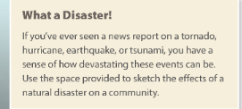page 543 | Symbol  Theme  Motif definitions (page 544) | Show teacher created poem | 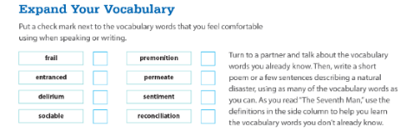  Look at the definitions that you don’t know after marking the words that you do know. | Write a short poem describing a natural disaster, using as many of the vocabulary words as you can. | Self-Check:  -Does your poem use at least three of the vocabulary words?  -Does your poem focus on a natural disaster?  -Is your poem at least 8 lines?
Tuesday | I am learning how to analyze and evaluate language in a variety of text.  I can identify figurative language.  I can analyze how figurative language contributes to the development of mood/theme. | What ideas/images come to mind when you think of the “trauma of a natural disaster”? (page 546) | What is mood? How is it different from tone? Mini Lesson | Pausing to prompt students while reading as a class:  Analyze symbol and theme page 550  Vocabulary page 551 (applying academic vocabulary-turn and talk)  Vocabulary in context page 552  Analyze symbol and theme page 553 | Annotate: In paragraphs 13-15, mark where the weather changes drastically  Analyze: How does the contrast in the descriptions of the weather change the mood of the story? |  | TOD:  Analyze figurative language page 548  How does personification enhance the author’s description of the storm’s momentum?
Wednesday | I am learning how to analyze and evaluate language in a variety of text.  I can identify figurative language.  I can analyze how figurative language contributes to the development of mood/theme. | Vocabulary in context page 554:  delirium: High fever or shock may cause delirium.  Someone experiencing “bouts of delirium” suffers from periods of mental confusion, hallucinations, or incoherent speech.  Why did the protagonist suffer from delirium? |  | Analyze symbol and theme page 555  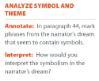  Vocabulary in context page 555:  - Describe the qualities of a sociable person  - What is the narrator’s premonition about?  Analyze symbol and theme page 557  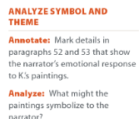  Vocabulary in context page 557  - What feeling is permeating the narrator’s body as he looks at K’s artwork? | Analyze figurative language page 558  Compare the figurative language the narrator uses to describe his memories compared with his present-day experience.  Vocabulary in context page 558-559  - Explain how the description of  the waves seeking reconciliation is an example of figurative language.  - Are you surprised that he shows little emotion about the town’s changes? Why not?  Quick check page 560  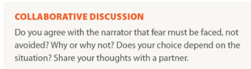 |  | TOD:  Assessment practice page 561
Thursday | I am learning how to analyze and evaluate language in a variety of text.  I can identify figurative language.  I can analyze how figurative language contributes to the development of mood/theme. | Answer the following question using at least one vocabulary word on page 564:  What was the story “The Seventh Man” about? | Review of simile, metaphor, and personification | Worked example #1 p 564 | t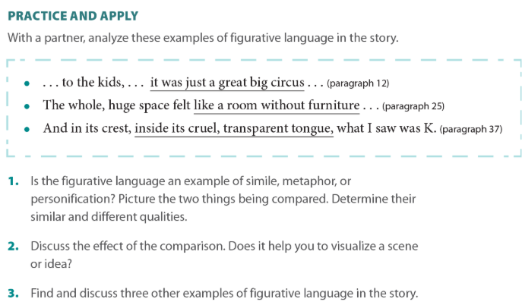 | 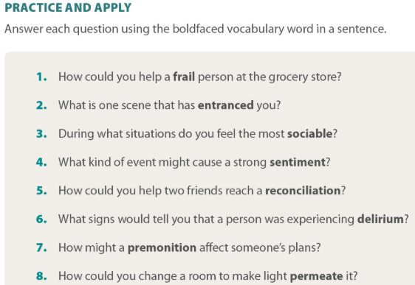
Friday |  |  |  |  |  | “The Seventh Man” Selection Test
*key literacy strategies

