Grade Level: 3rd Grade Dates: Sept 5th – Oct 5th
School Information  School: Copeland Elementary  School Code: 060043  Teachers: Brace, Denson, Rozier, Murdaugh  Buffer: Oct 5th –12th | Transdisciplinary Theme: Where We are In Place and Time  Segment of Theme: Interconnectedness of individuals and civilizations  Over Arching Concept: The students will understand that location affects a society’s economy, culture, and development
Section 1: Overview
- Central Idea: Location affects a Society’s economy, culture, and development
- Key Concepts: connections, causation, change
- Guiding Related Concepts: | - Lines of Inquiry: | - Teacher Questions (Guided Questions):
Resources, community, environment, landforms, | -Our physical location connects our community  -Environmental changes impact our development of society  -Resources may cause various outcomes in our economy. | DOK Level 3 & 4  Vocabulary: topographical features • physical features • topographic map • physical map • rivers • Mississippi River • Ohio River •Rio Grande • Colorado River • Hudson • St. Lawrence • mountains • mountain ranges • Appalachian Mountains • Rocky Mountains • equator • prime meridian • latitude • longitude • globe • identify • locate • describe •compare •contrast •  Location:  1. How can we describe our country’s land and water?  a. Why are land and water features important?  b. What are the major rivers in our country and how have they shaped culture?  c. How can mountains affect our history?  2. How can we describe locations in our country?  a. What features of globes and maps help us identify locations?  b. Why do we have an equator, prime meridian, and lines of latitude and longitude on globes and maps?  c. How can cardinal and intermediate directions help us locate features of our country?
- Prior Content Knowledge: | - Assessing the Lines of Inquiry:
Students should be familiar with maps, legends, and a Georgia landforms. | How will you assess student’s understanding of the lines of inquiry?  Students will name some topographical features they have learned before. Use a Frayer model or another visual organizer to define mountain…elicit from students a definition, examples, non-example.  Build a class compare/contrast chart of the two main mountain ranges, divide the class into two parts and have them explore informational text online or in books or magazines to gather information  Draw and label the 6 major rivers in their correct locations
Section 2: What Are Our Target Goals?
- Concept Based Summative Assessment: | - Targeted Approaches to Learning (highlight 3): | - Targeted Learner Profile Attributes (highlight 2):
Diorama  Students will be assigned a region of Georgia. Students will create and identify the landforms and resources in that area. Students will have a choice on what methods and materials they use to create the diorama. Students will use a checklist rubric to self asses their work.  ( The diorama will assess that the students are familiar with the region that was assigned to them. It will also show that they know how to identify the landforms and resources in that area). | Social Skills, Research Skills, Communication Skills. Thinking Skills, Self-Management Skills | well-balanced, caring, principled, open-minded, risk taker, knowledgeable, communicator, reflective, thinker, inquirer
Section 3: What Assessments will be provided in this unit of inquiry?
- Pre-Assessments:  What assessment will be given at the beginning of the unit to inform current understanding | - Formative Content Based Assessments:  What assessments will be given to monitor student learning of content? | - Summative Content Based Assessments:  What assessments will be given for students to show mastery of unit content?
Canvas Pre Unit Test  SS3G1, SS3G2 | Canvas Informal checks ( Unit2 Geography Informal Progress Check) | Canvas Post Unit Test. SS3G1, SS3G2  Map location assessment
Section 4: How will we Facilitate Learning?
- Provocation:  How will interest into this unit be sparked? | - Learning Experiences:  What activities/experiences will help facilitate the learning? | - Evidence of Differentiation:  How will the learning experiences be adjusted to different learning styles/abilities?
Give students different resources to create a certain outcome to build bridge (cotton balls, toothpicks, etc)  This provocation is connected to our central idea. It gives students an opportunity to make connections about what resources you have determine how you build things ( economy). By the students being put into groups like a community and not having the same materials, it will help them understand how the resources in your community are helpful and how much easier or harder it can be.. | Ain’t no mountain High enough and Take me to the River  Ask students if they know the word Geography. Break it into parts and explain that geo (Greek) means earth and graphy (Greek) means a drawing or recording process. If students are keeping a visual journal or interactive notebook, have them write and draw geo + graphy and sketch a hint as to the meaning of each word part. Ask students to name some features they have learned before. Use a Frayer model or another visual organizer to define mountain…elicit from students a definition, examples, non-example  -Dueling Mountain Ranges  – Show students a physical map of the United States. Ask them why they think this is called a physical map (because it shows land and water features, not political or man-made features like state boundaries, cities, counties, etc.) If you have access to raised relief maps of the U.S., these are even better to use because students can actually feel the contours of the features. Tell them that there are two major mountain ranges in the U.S. and other smaller ones. Can they find the two major ones? (Rockies and Appalachians) Ask them to study the map carefully and begin to notice similarities and differences. Build a class compare/contrast chart of the two main mountain ranges, like the one below. You can divide the class into two parts and have them explore informational text online or in books or magazines to gather information  -Rivers, Rivers, Rivers  Divide the class into groups and assign each group a river to research. Gather books, magazines, images, useful websites with information on these rivers and have students work together to collect data for the chart. – Pull out the U.S. maps students have labeled with the two major mountain ranges, and have them now draw and label the 6 major rivers in their correct locations | - Students will be able to make an audio recording using seesaw, draw pictures, circling or labeling their map.  - They will be able to work with partners, and we will model what is required.  - Have books that are included on Myon that has the read aloud features.  - Give some of the students the organizers needed partially completed to lessen the amount of work.  - Give some students labeled maps with a color key.
- Learning Experiences in Specials:  How are Specials Courses able to connect to this unit? | - Local/National/Global Connections:  How can we connect the content to local/national/global issues? | - Student Action:  What learning experiences support potential student-initiated action?
Spanish  Ss will be connected to this unit through the concept: “Connection” They will make a mural about some “Hispanic Countries” and they’ll inquiry about how these countries are related. | Students compare and contrast our resources to the country flag that they are assigned. Classrooms have been assigned a country to learn throughout the year. We will incorporate this learning experiences throughout the school year to make sure the students know about their country. about to make sure . | -Students can come up with ways that they can better use resources that are in our school and local area and present to administration.
- Student Agency and Play:  What learning experiences provide students with voice, choice and ownership? What play opportunities will be provided by Kindergarten/Pre-K? hands on/STEAM for K-5? |  | - Resources:  Which resources will you and the students use? This may include people, places, technologies, learning spaces and physical materials.
Students will have free choice on methods and materials they will use to create their diorama. |  | Provocation to unit: cottonballs, toothpicks, straws, popsicle sticks, tape & string.  Laptops, worksheets, graphic organizers, kiddle.com, Myon
Section 5: Reflection (Write the year, change font color for each year)
- Reflect on learning experiences:
Rozier- Students were able to read, label, and relate personal experiences when discussing locations of the major rivers of the United States and mountain ranges. Students were given reading passages and graphic organizers for each reading about each major river. They were also given a graphic organizer for mountain ranges as well. In groups, students were able to create a bridge that represented a resource used to transport over rivers.

Denson: Students were a able to learn about how we get resources from where we are located based on what materials they were given to build the bridges. The students learned to work as a team to figure out ways to find a way to build their bridge. It was a lot of trial and error, but overall it was a great activity.
- How were the tasks differentiated to meet different learning styles? |  | - How did the learning experiences and strategies we used throughout the unit help to develop and show students understanding of the central idea?
Rozier- The reading passages given were differentiated for learning style of students within the classroom. They were able to gain knowledge of the mountain ranges and rivers with understanding the locations.  Denson- Students had various reading passages and also for the bridges were put in homogeneous groups so that they could use other students to assist them. They also were able to recognize the locations of the various rivers.  Gist- Student were allowed more time to complete their bridges and their reading passages were differentiated. Students due to IEPs also received modeled and small group instruction to complete the task with the collab teacher included. Auditory, Visual, and Kinestetic learning strategies were implemented to meet the needs of all learners. Translation was used for ELL stduents who speak only Spanish.  Brace- We used differentiated reading passages and allowed students to work at their pace. Students also had various methods to display or communicate by learning, writing, drawing and speech. |  | Rozier- Students were able to view the rivers on the map to determine how the location of the rivers affected the society’s economy, culture, and development. Students mention the different jobs that were available if certain states were near each river or mountain range. Students were able to compare where they live (culture) to the states that had these major rivers and mountain ranges near.  Denson- Students were able to identify the mountain ranges and rivers. They also realized how important resources were based on your location.  Gist- The learning experience of creating the bridge allowed the students to really work on their social skills since they were working in groups, which is something that we have been working on as a class. Implementing this activity allowed the students to take higher level of thinking as they had to plan, create, and implement in collaborative groups. They connected the activity to their real lives as they learned that their location and what around them affects the execution and outcomes of situations and resources available to them.  Brace- Students really connected with how the resources and how it affects their culture. Students compared where they live to people in other places..  .
- What learning experiences best supported students’ development and demonstration of the attributes of the learner profile and approaches to learning? |  | - How effective were the summative assessments in measuring student learning? What, if any, changes need to be made to the assessments?
Rozier- Creating the bridge during the provocation allowed students to use communication, research, and social skills. Students were able to research with the teacher what a bridge is. They were then assigned to groups to build there bridge using materials that were given. Communication and social skills were vital when creating the bridge effectively.  Gist- Students were great thinkers when it came to doing the bridge activity. I placed my students in groups and it allowed them to work as a team to come up with a result that were to their liking. They were able to be reflective as well as great communicators. Student engaged in higher order thinking as they communicated and shared their thoughts as well as asking and answering questions to their peers as they completed the activities.  Denson-I think the bridges were a great activity to allow the students to have conductive struggle until they were able to figure out a way to build their bridge. The thinking skills exhibited during this time was very interesting to watch. Self- management was also a skill that was exhibited although it took a second. Encouraging Students “state of mind” was needed in order for them to complete their bridge.  Brace- Students used their communication skills amongst one another to develop a plan so that they could build their bridge. They also had to use their thinking skills to decide which resources they would use wear to build their bridges. |  | Rozier- Students were able to complete the summative assessment on Canvas. We weren’t able to complete the diorama.  Denson: Again we end up not having enough time to complete all of the assessments that we put in the Unit planner. But students were able to demonstrate in a myriad of ways that they showed understanding of the information.  Brace- Students weren’t able to complete the diorama in which we envisioned based on time restraints. Next year I suggest completing a reflection in Seesaw.  Gist- Assessments scheduled during this time affected our planned out scheduled. Students were able to complete the district required assessments that were required. There are also diagnostic assessments that were administered that were required of the students which altered instructional time greatly.
- What student-initiated inquiries (questions) arose from this unit of inquiry? |  | - What student action arose from this unit of inquiry?
Rozier- Why are land and water features important?  Why do regions have different landforms?  What are resources?  Denson- What is Geography?  What are Resources?  What would happened if we didn’t have rivers or water?  Gist- Why do we need resources?  What are some local resources?  Explain how resources help you in your everyday lives?  What can you predict about other resources around the world?  Brace- How do you know something is a resource?  What is Geography? |  | Rozier- Students took control of their own learning by creating the bridge during the provocation and writing reflective pieces after creating them. Students also decided to present their bridge and discuss how they were alike and different from their peers.  Denson-Students begin to make connections based on where we are and local businesses. They were also able to see trends in resources that certain businesses and places lack.  Gist- Students begin to notice all types of resources that were being used daily in various places. They also wanted to keep making improvements on their bridges even though the time for the project was up. As they learned more and began to understand the views of their peers, they wanted to test out their predictions and adjust their engineering of the bridges.  Brace- Students noticed the bridges in the local area and inquired about what resources were used. After showing them bridges around the world they begin to think of ways they could have made their bridges better.
- Any additional notes or changes that need to be considered next year?
As a grade level it is important that we take into account the amount of activities that the students are expected to within the certain schedule changes. This year we reduced amount of assessments and planned using the School Calendar, but still found ourselves being cut on time. Finally making sure we incorporate our Class country a little more for compare and contrast. Student conversations focused and always came back to mainly businesses, places here in the United states. There were also many activities that were on the school calendar that were extended in time which drastically cut into instructional time with our units. While we were able to to still implement the unit with fidelity we will continue to ensure we carve out time in planning to account for the other activities if they exceed the allotted school calendar planned times.

Spanish:
Ss were very curious by learning about some Hispanic countries, their culture and their influence in the US. Some Hispanic Ss shared some information about their countries and culture.
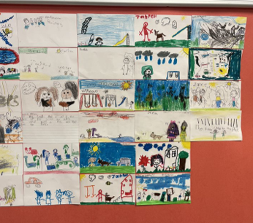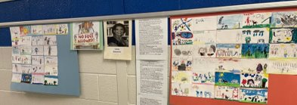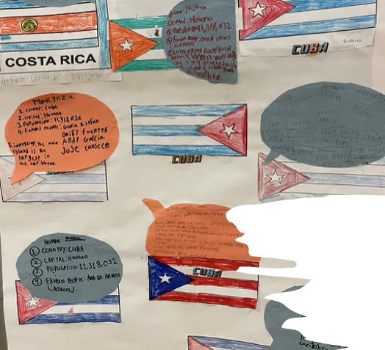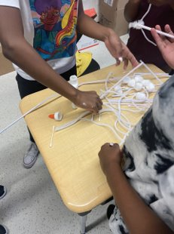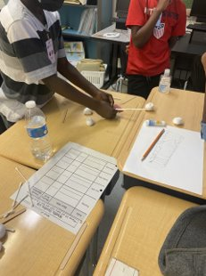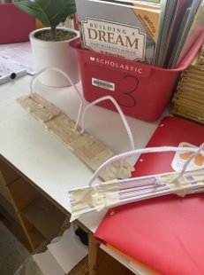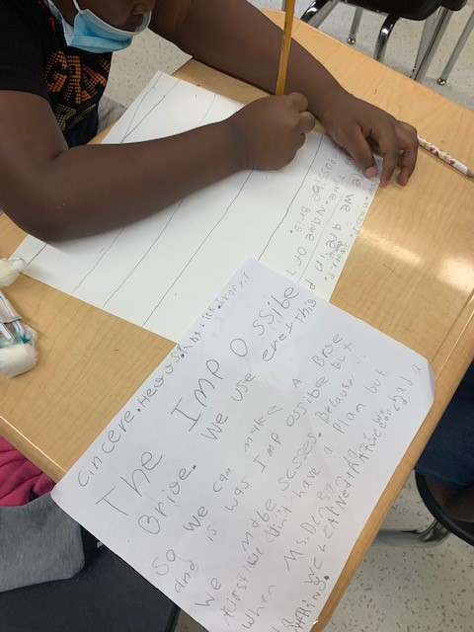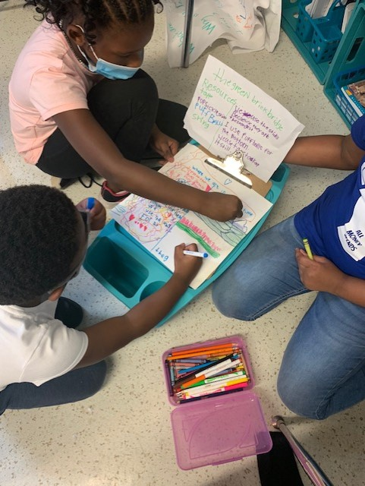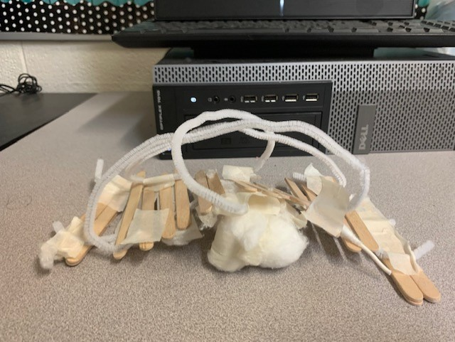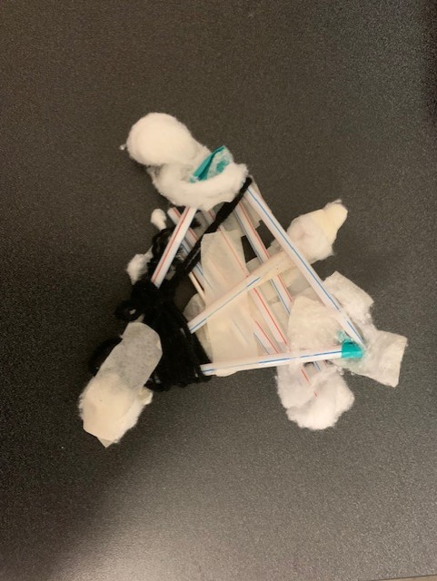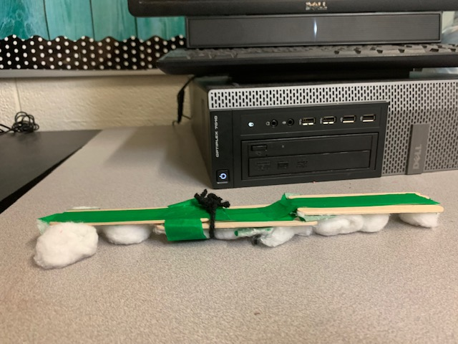
**Scroll Down for Unit Standards**

Unit Standards:

ELA: ELAGSE3SL1: Engage effectively in a range of collaborative discussions (one-on-one, in groups, and teacher-led) with diverse partners on grade 3 topics and texts, building on others’ ideas and expressing their own clearly. c. Ask questions to check understanding of information presented, stay on topic, and link their comments to the remarks of others. d. Explain their own ideas and understanding in light of the discussion

ELAGSE3RI4: Determine the meaning of general academic and domain-specific words and phrases in a text relevant to a grade 3 topic or subject area.

ELAGSE3RI9: Compare and contrast the most important points and key details

ELAGSE3W7: Conduct short research projects that build knowledge about a topic. ELAGSE3W8: Recall information from experience or gather information from print and digital sources; take brief notes on sources and sort evidence into provided categories.

Math: n/a

Science: n/a

Social Studies:
SS3G1 Locate major topographical features on a physical map of the United States. a. Locate major rivers of the United States of America: Mississippi, Ohio, Rio Grande, Colorado, Hudson, and St. Lawrence. b. Locate major mountain ranges of the United States of America: Appalachian, Rocky.

SS3G2 Locate and describe the equator, prime meridian, and lines of latitude and longitude on a globe.

