The Psychology of AIDS and HIV

BELL RINGER: Analyze the political cartoon featuring President and Mrs. George H.W. Bush and write a brief summary that explains the creator’s intended message.

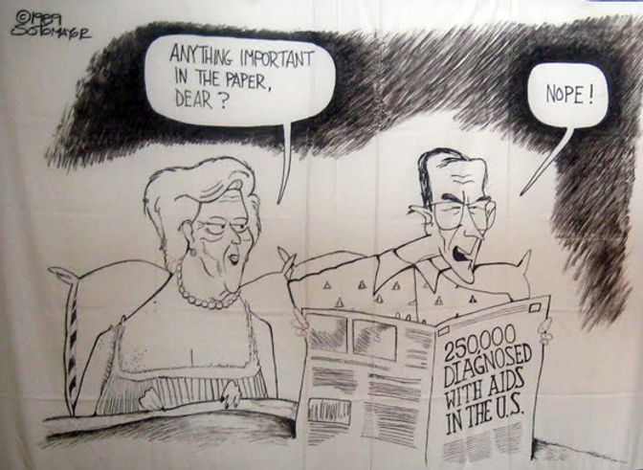

_________________________________________________________________________________________________________________________________________________________________________________________________________________________________________________________________________________________________________________________________________________________________________________________________________________________________________

Georgia Standard of Excellence

SSPVB3 Identify psychological disorders and treatment.

I Can Statement:

I can analyze and describe how being diagnosed with HIV can affect a person’s mental and emotional health.

Success Criteria:

We will know that we are successful when we can describe how being diagnosed with HIV can affect a person’s mental health.

HIV and AIDS and Mental Health

What is HIV?

HIV, or human immunodeficiency virus, is the virus that causes AIDS (acquired immunodeficiency syndrome). HIV can be transmitted during sexual intercourse, by sharing syringes, or during pregnancy, childbirth, or breastfeeding.

HIV weakens the immune system by destroying CD4+ T cells, a type of white blood cell that is important for fighting off infections. The loss of these cells means that people living with HIV are more vulnerable to other infections and diseases.

Today, effective anti-HIV medications allow people with HIV to lead long, healthy lives. When taken as prescribed, these daily medications, called antiretroviral therapy (ART), can suppress the amount of virus in the blood to a level so low that it is undetectable by standard tests.

Why are people with HIV and AIDS at a higher risk for mental disorders?

The stress associated with living with a serious illness or condition, such as HIV, can affect a person’s mental health. People with HIV have a higher chance of developing mood, anxiety, and cognitive disorders. For example, depression is one of the most common mental health conditions faced by people with HIV.

It is important to remember that mental disorders are treatable. People who have a mental disorder can recover.

HIV and related infections can also affect the brain and the rest of the nervous system. This may change how a person thinks and behaves. Also, some medications used to treat HIV may have side effects that affect a person's mental health.

Situations that can contribute to mental health problems for anyone:

Having trouble getting mental health services

Experiencing a loss of social support, resulting in isolation

Experiencing a loss of employment or worries about being able to perform at work

Dealing with loss, including the loss of relationships or the death of loved ones

In addition, people with HIV include may also experience situations that negatively impact their mental health, such as:

Having to tell others about an HIV diagnosis

Managing HIV medicines and medical treatment

Facing stigma and discrimination associated with HIV/AIDS

Understanding how living with HIV can affect mental health and knowing what resources are available can make it easier for people to manage their overall health and well-being.

Activity: Write a summary that explains what HIV is and also how being diagnosed with HIV can impact a person’s mental health.

_________________________________________________________________________________________________________________________________________________________________________________________________________________________________________________________________________________________________________________________________________________________________________________________________________________________________________

