Rubicon- Notes (feedback for lesson plans)
- Go to www.rcboe.rubiconatlas.org.  - Log in. | 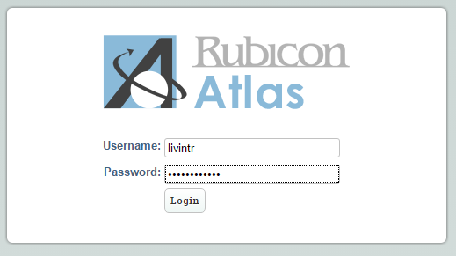
- Hover over the ‘Search’ tab and choose ‘Lesson Plans/Tasks’. |   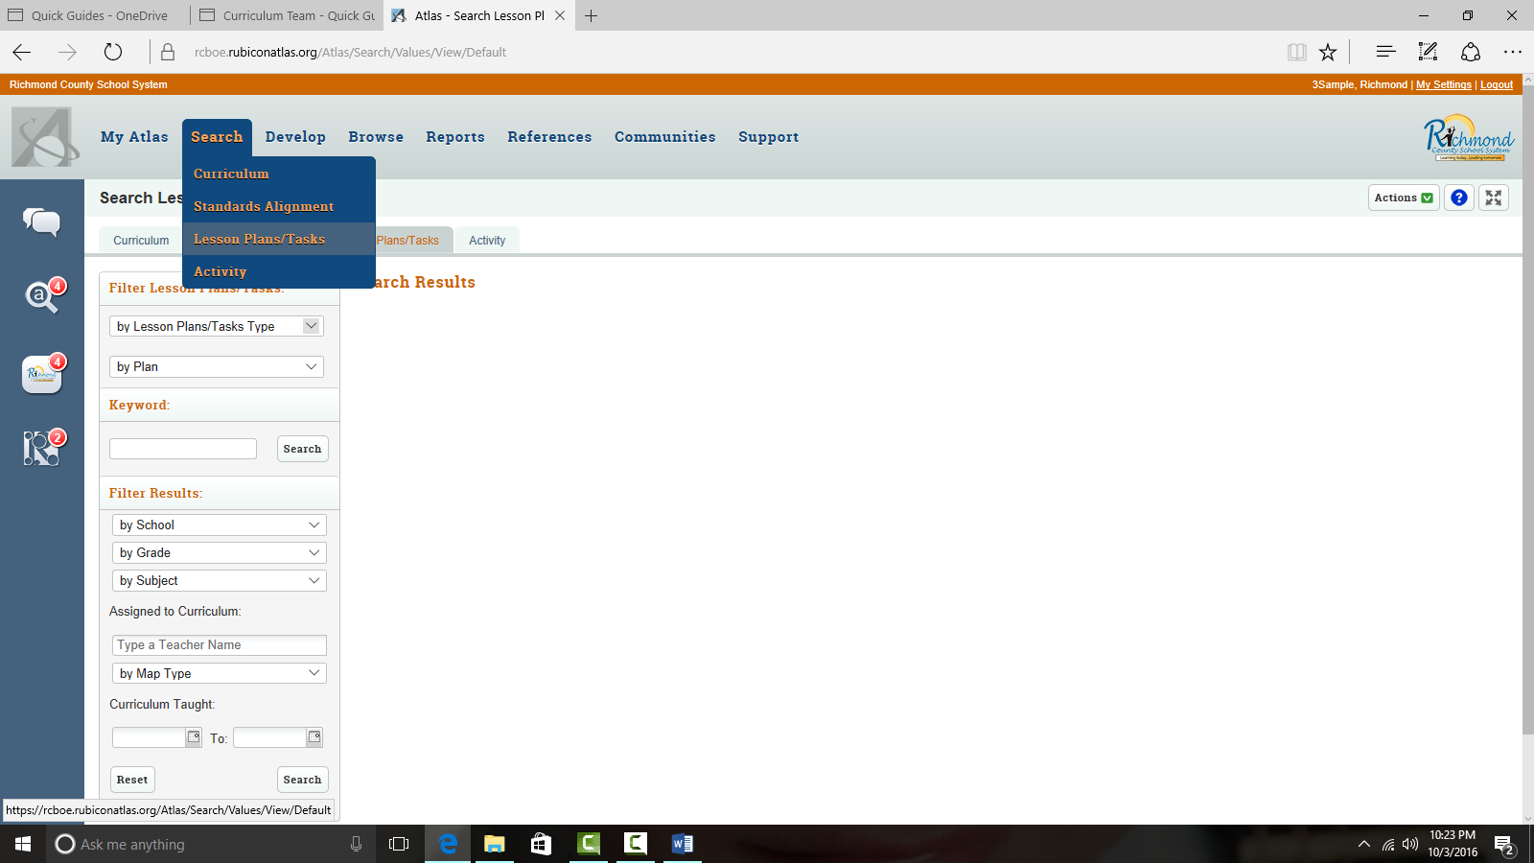
- Type the teacher’s name in the ‘Assigned to Curriculum’ field and select your name from the resulting list.  - Click ‘Search’. | 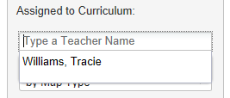  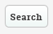
A list of all your lesson plans will appear.  - Click on the lesson plan you want to review. | 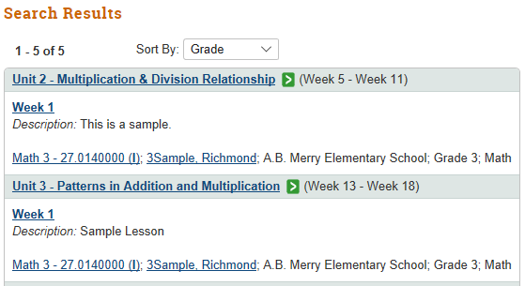
- After reviewing the lesson plan, click on the green arrow box to provide feedback with a note.  - Click ‘Leave a Note’. | 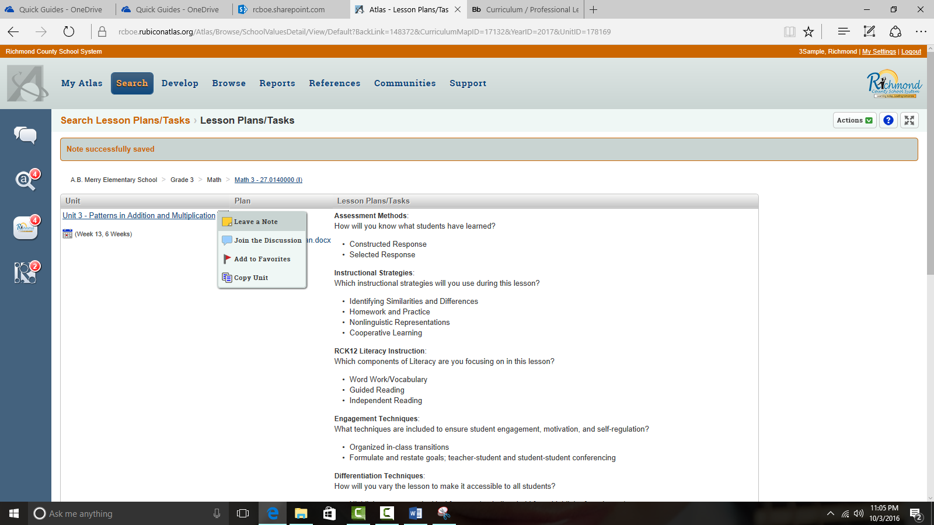
- In the ‘Subject’ field type the lesson. This will allow the teacher to know which lesson you are providing feedback on.  In the box indicated, type your feedback.  Click ‘Save’. | 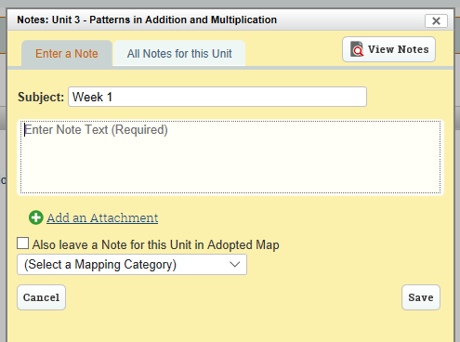
Reading a Note

- To retrieve a note, click on the Communication Channel icon. | 
- The resulting list will show you the notes that have been left for you.  You can click on the unit to view the entire lesson plan and make adjustments if necessary. | 