Standards:
9.P.EICC.4.a Establish a purpose and goals for writing and identify a target audience.
9.P.EICC.2.c Explain and learn concepts and processes by interpreting and constructing texts.
9.P.EICC.3.g Determine the meanings of unfamiliar words and concepts by applying knowledge of context and of academic vocabulary and word parts.
9.L.V.3.d Use available print and/or digital resources, including reference materials, style guides, digital tools (e.g., online searches, embedded word processing features) to determine, clarify, or verify the meaning of unknown or multiple-meaning words and phrases.
9.P.EICC.2.d Interpret and construct texts to aid the analysis and evaluation of texts and ideas.
9.T.SS.1.a Analyze the effectiveness of a text’s organizational structure to meet the needs and expectations of the target audience.
9.P.AC.1.a Identify, apply, and analyze the literary, expository, and opinion (grades K-5) or rhetorical (grades 6-12) elements in texts, explaining or evaluating how specific elements affect the target audience and support the text’s purpose.
9.L.V.3.e Make strategic language decisions when writing or speaking by determining, clarifying, or verifying the nuanced meanings of closely related words or phrases using available print and/or digital resources.
9.T.SS.2.a Analyze how the use of figurative, connotative, and/or rhetorical language contributes to the development of meaning, tone, or mood in a wide variety of texts.
9.T.T.3.b Recognize and analyze the use of rhetorical appeals (ethos, logos, and pathos) in a variety of texts.
9.P.ST.1.b Consider how context impacts the purposes of the author and the audience.
9.L.GC.2.e Recognize and use parallel structure within a sentence to create symmetry and convey a congruence of ideas.
9.P.ST.2.c Draw from knowledge of how authors consider context and audience to determine which information and ideas to highlight, which text design is most accessible, which word choices and language structures are most effective, and which craft techniques are most impactful.
9.P.AC.1.d Describe, analyze, and evaluate the design and organization of the text, explaining how specific formats, structures, patterns, and features influence the audience, contribute to the text’s accessibility, and support the text’s purpose.
9.P.AC.1.b Identify, apply, and analyze important, interesting, or effective uses of language, explaining or evaluating how specific word choices affect the target audience and support the text’s purpose.
9.P.EICC.4.d Link ideas and information to the organization plan, highlighting ideas and information that are most relevant, useful, and impactful.
9.P.ST.2.b Draw from knowledge of author, audience, and context to discern and establish a clear point of view or unique perspective when interpreting and constructing texts.
9.P.AC.2.a Integrate literary, expository, and opinion (grades K-5) or rhetorical (grades 6-12) elements to appeal to target audiences and achieve specific purposes.
9.T.T.3.a Read, discuss, evaluate, and critique a variety of texts, considering the argumentative techniques used to present and design content and their associated implications on meaning or central idea.
9.T.SS.1.d Apply knowledge of text structure and organization to create coherent and cohesive texts with an introduction that guides the focus and captures the audience; purposefully organized and developed supporting facts, reasons, explanations, details, descriptions, and/or events; and a memorable conclusion.
9.T.C.1.a Use knowledge of texts’ distinct disciplinary, personal, or technical purposes to aid comprehension.
9.P.ST.2.a Develop and apply knowledge of author, audience, and context to discern and establish the purpose of texts being interpreted or constructed and to evaluate the extent to which those texts achieve those purposes.
9.T.T.2.a Analyze and evaluate the use and effect of expository techniques and organizational patterns.
9.L.GC.1 GUM:
Use periods, exclamation marks, and question marks at the end of sentences.
Recognize and use conventional capitalization in abbreviations, proper adjectives, and formal titles.
 | Pre-Teaching    Learning Target    Success Criteria 1  Success Criteria 2 | Activation of Learning  (5 min) | Focused Instruction  (10 min)  *I DO | Guided Instruction  (10 min)  *WE DO | Collaborative  Learning  (10 min)  *Y’ALL DO | Independent Learning  (10 min)  *YOU DO | Closing  (5 min)
 |  | - Do Now  - Quick Write*  - Think/Pair/Share  - Polls  - Notice/Wonder  - Number Talks  - Engaging Video  - Open-Ended Question | - Think Aloud  - Visuals  - Demonstration  - Analogies*  - Worked Examples  - Nearpod Activity  - Mnemonic Devices* | - Socratic Seminar *  - Call/Response  - Probing Questions  - Graphic Organizer  - Nearpod Activity  - Digital Whiteboard | - Jigsaw*  - Discussions*  - Expert Groups  - Labs  - Stations  - Think/Pair/Share  - Create Visuals  - Gallery Walk | - Written Response*  - Digital Portfolio  - Presentation  - Canvas Assignment  - Choice Board  - Independent Project  - Portfolio | - Group Discussion  - Exit Ticket  - 3-2-1  - Parking Lot  - Journaling*  - Nearpod
Monday | I am learning how to identify and analyze important, interesting, or effective uses of language, explaining or evaluating how specific word choices affect the target audience and support the text’s purpose.  I can identify interesting word or structure choices in the speech.  I can analyze those choices and their impact on his purpose and message. | Do you have a dream for the United States? Sketch or make a list of changes that would move the country toward your vision of a “more perfect union” (HMH page 464) | Background slide on MLK  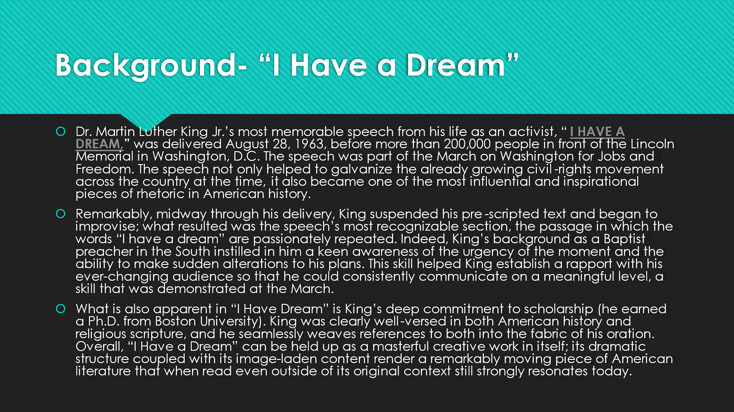 | I Have a Dream speech by Martin Luther King .Jr HD (subtitled)  Martin Luther King - I Have A Dream Speech - August 28, 1963  As you watch the video, follow along in your textbook and underline interesting word choice or phrases that stand out to you. | Read: I Have a Dream by MLK page 467-472  467  Annotate: Underline King’s claim. Mark details and evidence in paragraphs 3-5 that support his claim. Analyze: What does King believe should happen?  470  Annotate: Mark the phrase that is represented throughout paragraphs 11-15. Connect: How does the meaning of this phrase change as King repeats it?  470  Notice and Note: Mark the quotations Dr. King uses in paragraph 15. Analyze: What is he quoting from? Why is this effective? |  | Does King believe it possible to integrate Blacks and whites in the United States? Use evidence from the text to support your answer.
Tuesday | I am learning how to use periods, exclamation marks, and question marks at the end of sentences.  I am learning how to recognize and use conventional capitalization in abbreviations, proper adjectives, and formal titles.  I can complete with at least 70% accuracy using the Canvas interact assignment.  I can write a sentence that uses appropriate punctuation mark at the end of the sentence and uses an abbreviation. | Test Tip Tuesday Slides 8-9 (PowerPoint from district)  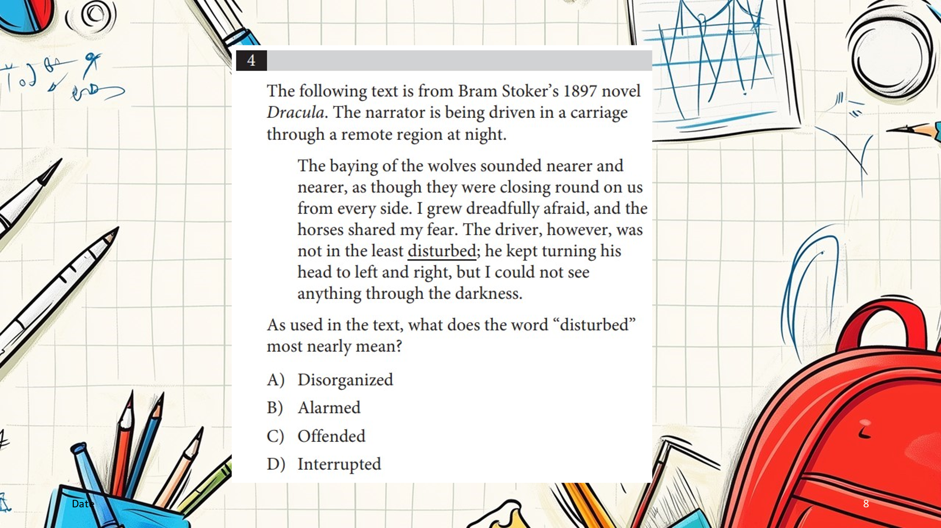 |  |  |  | End Marks and Abbreviations Interaction Grammar Lessons on HMH  End Marks and Abbreviations - HMH-ELA NGLit 2020 NA 09 GS E M11  Print and have posted around the room for students to practice. | Write a sentence that has proper punctuation at the end of the sentence and has at least one abbreviation used properly.
Wednesday | I am learning how to identify examples of rhetorical devices in a speech.  I can find examples of rhetorical devices in a speech.  I can correctly identify those examples. | Martin Luther King Jr.’s speech cautions against “bitterness and hatred” that can take hold when people are treated unfairly. IN paragraph 8, he argues for controlling these feelings and developing self-discipline in the struggle for equality.  Think about how you feel when you see another person or group treated unfairly.  Self-control and self-discipline can help students respond positively in such situations. Dr. King, who dedicated his life to racial justice and whose tireless efforts still inspire us.  What strategies can help people react to difficult situations with self-control and self-discipline? |  |  | With a partner complete the rhetorical devices scavenger hunt for the “I Have a Dream” speech. |  | Look at the following allusion from MLK’s “I Have a Dream” speech. Why does MLK use this allusion? How might it have impacted his audience?  “Five score years ago, a great American, in whose symbolic shadow we stand today, signed the Emancipation Proclamation. This momentous decree came as a great beacon light of hope to millions of Negro slaves who had been seared in the flames of withering injustice.”
Thursday | Asynchronous Day  I am learning how to identify rhetorical appeals in a speech.  I can find an example of ethos, pathos, and logos.  I can explain which rhetorical appeal MLK used the most effectively. | Asynchronous Day | Asynchronous Day | Asynchronous Day | Asynchronous Day | Asynchronous Day  On Canvas:  Complete the rhetorical appeals scavenger hunt of MLK’s “I Have a Dream” speech. You need to highlight 7 examples and have at least one example of each type of rhetorical appeal.  Which rhetorical appeal did he use the most effectively? | Asynchronous Day
Friday | NO SCHOOL | NO SCHOOL | NO SCHOOL | NO SCHOOL | NO SCHOOL | NO SCHOOL | NO SCHOOL
cabulary*key literacy strategies

